# AMAZON ELASTIC COMPUTE CLOUD (EC2)

**Amazon Elastic Block Store (EBS)** is a high-performance block storage service used with Amazon EC2 instances, providing persistent storage that can be attached and detached, and used for **data storage and transfer**, including **creating snapshots** for **backups and disaster recovery.**

To connect an **EBS (Elastic Block Store)** volume to an **EC2 instance** **within the same AWS availability zone**, follow these steps:

**To Launch EC2 Instance**

Compute 🡪 EC2 🡪 Instance 🡪 Launch Instance 🡪 Name 🡪AMS’S

**[ Amazon Linux 2023 AMI ]** 🡪 X86 (Architecture) 🡪 Instance **type:** t2.micro

(1 CPU & 1GB RAM) 🡪 Key pair 🡪 Name 🡪 **RSA**  🡪  **.Pem (open ssh )**

🡪 Save 🡪 Network setting 🡪 edit 🡪 Subnet 🡪 Availability zone (us-east-1) 🡪

Select existing security group 🡪 ssh -security group 🡪 configure storage

**Step1:** In the **AWS Services** search bar, type **EC2** and click on **EC2** to open the **EC2 Dashboard**

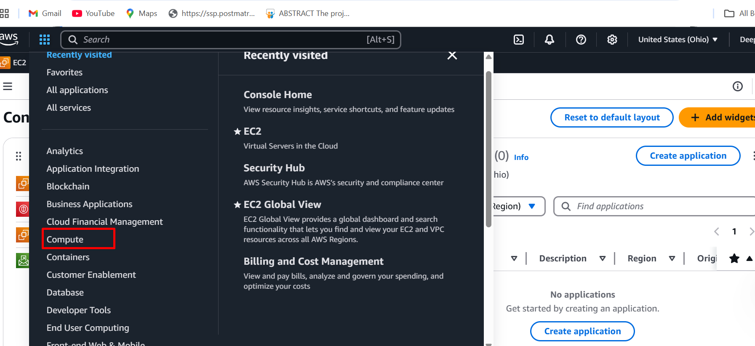

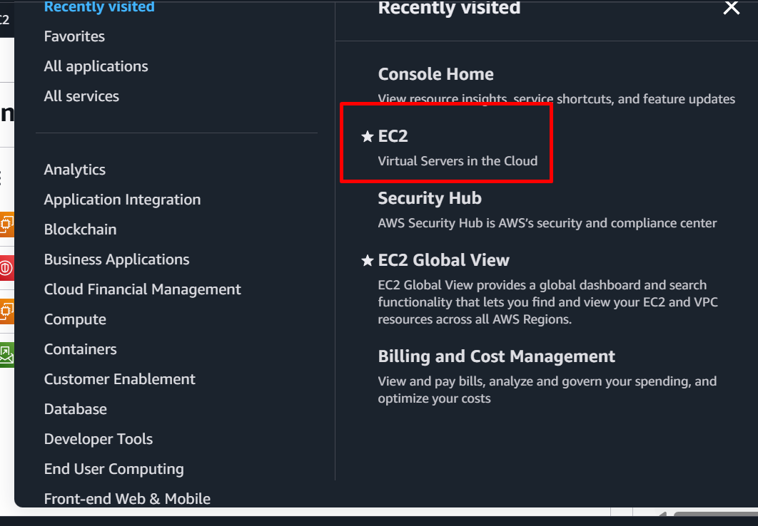

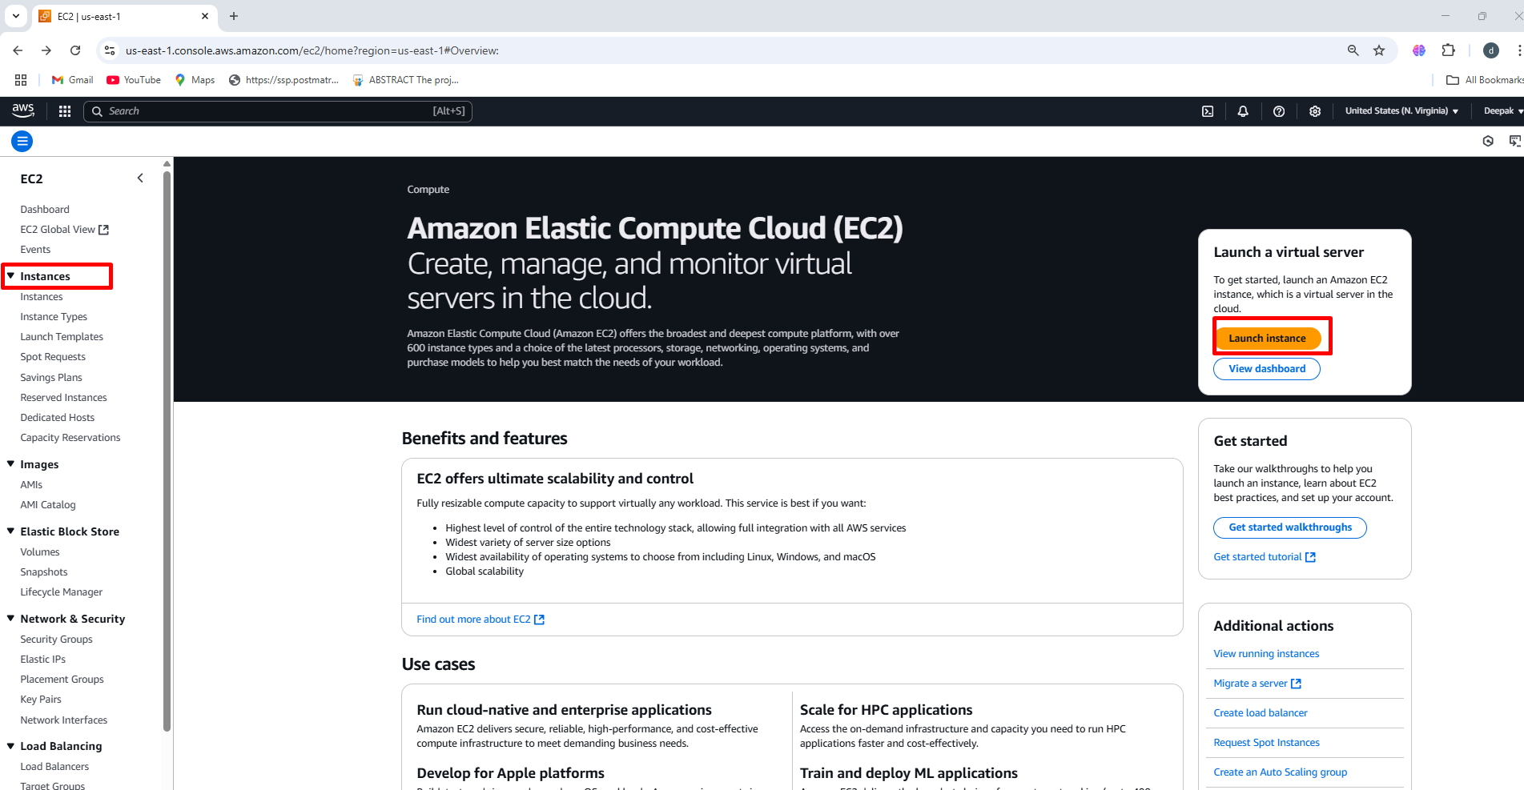

**Step2:** Enter the instance **name** Linux-server-1

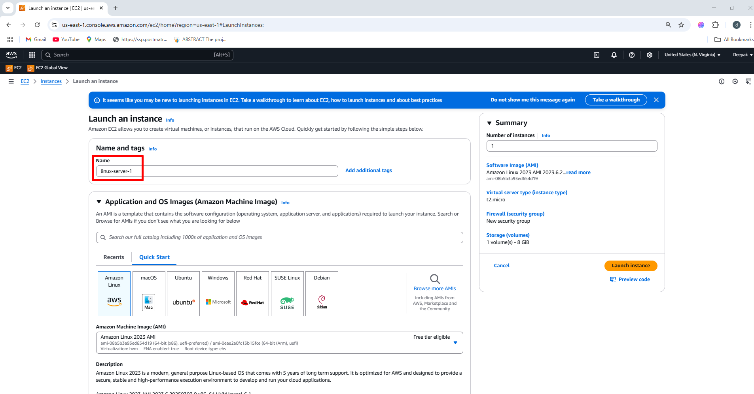

**Step3:** Choose the Amazon machine image (Amazon Linux 2023 AMI)

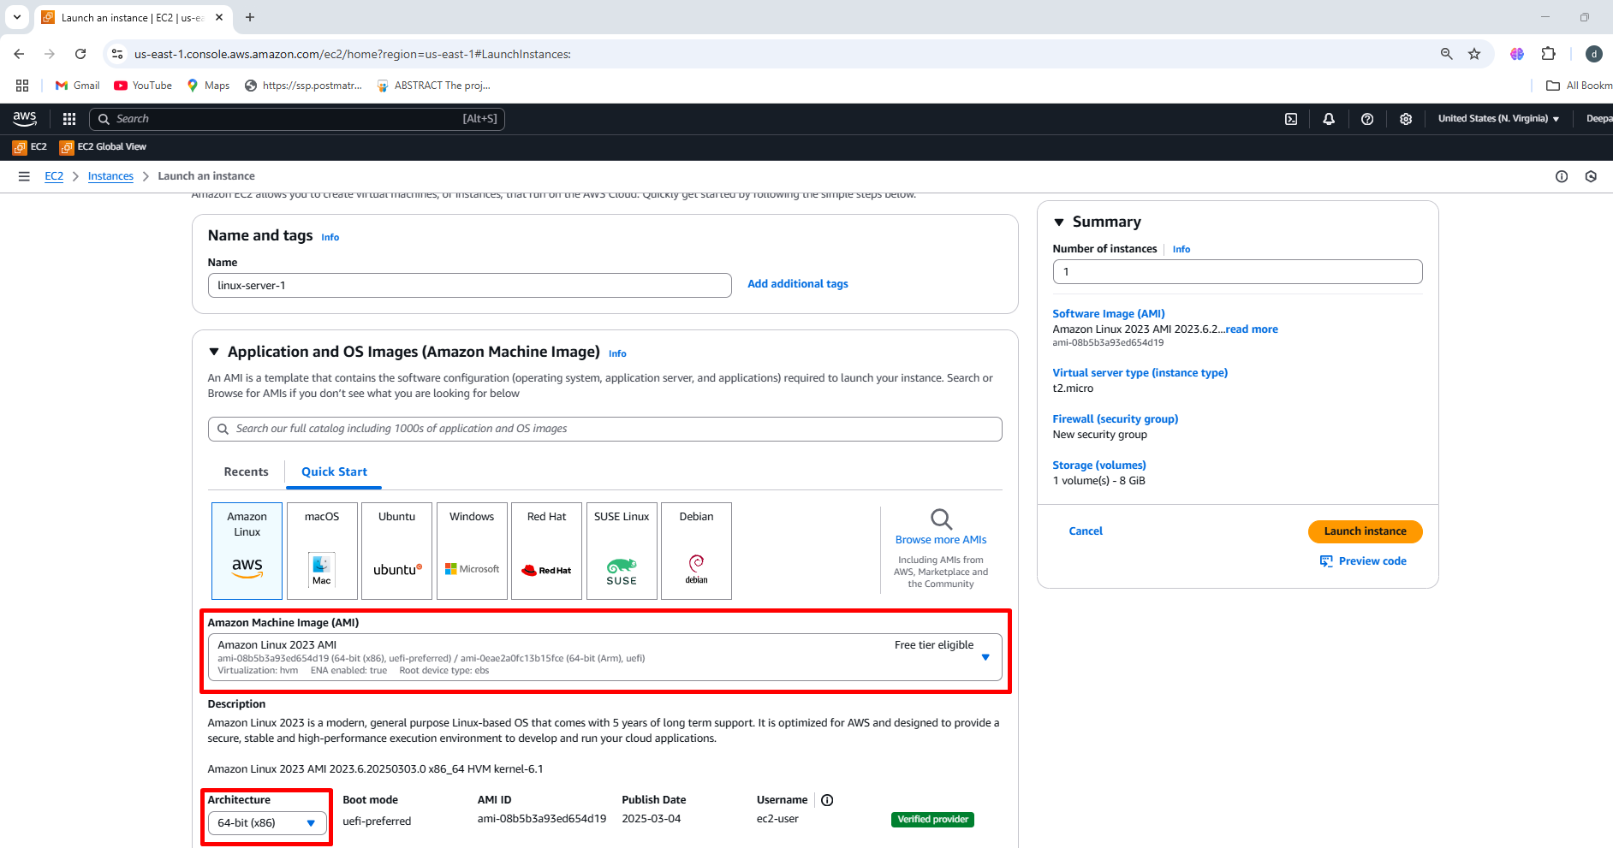

**Step4:** Select the instance type (**t2.micro 1cpu, 1GB RAM)**

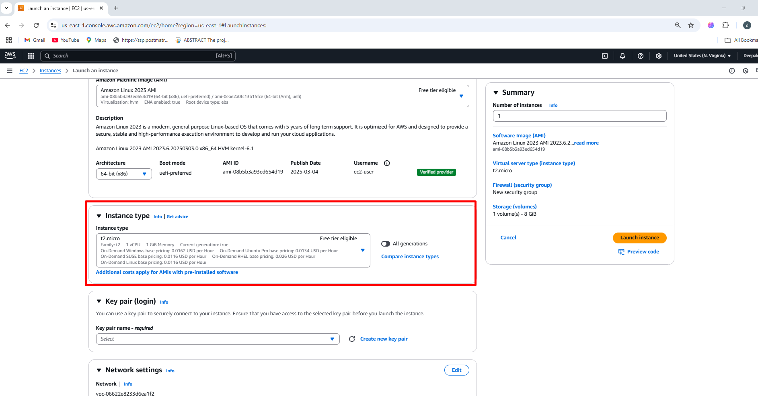

**Step5:** Create **key pair** to connect to the instance

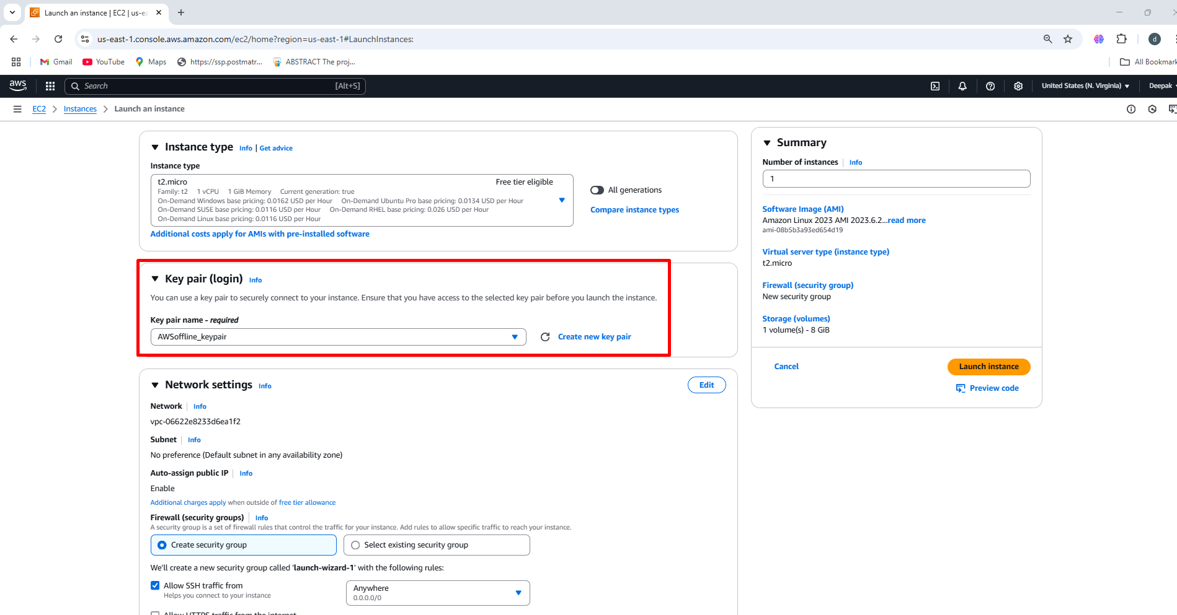

**Create an security group**

Security 🡪 Create Security Group 🡪 Name 🡪 Description 🡪 Inbound 🡪

Add Rule (ssh 22) 🡪 Anywhere (IPV4) 🡪 Create Security Group

Under network setting 🡪 Existing Security Group 🡪 Select the security group 🡪 Storage **{8 GB Linux}** 🡪 Launch Instance

**Step1:** Under the network settings edit and add subnet (us -east-1a) 🡪 add availability zone 🡪 select existing security group 🡪 ssh-security-group

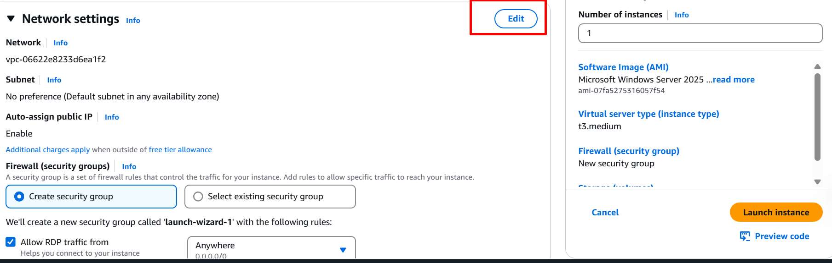

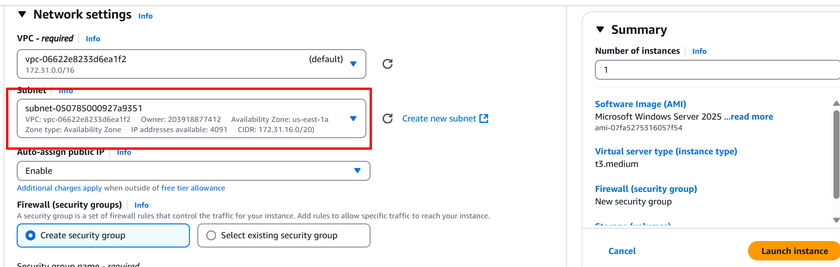

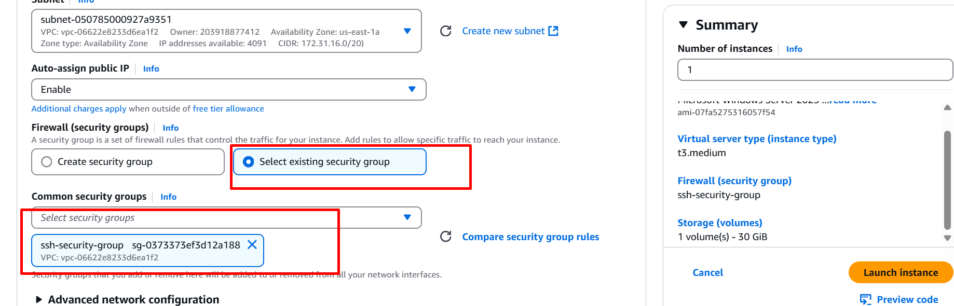

**Step2:** Select the **storage 8 GB** 🡪 launch instance

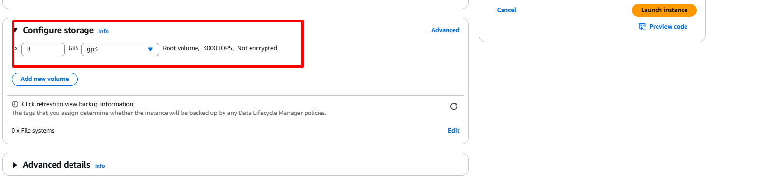

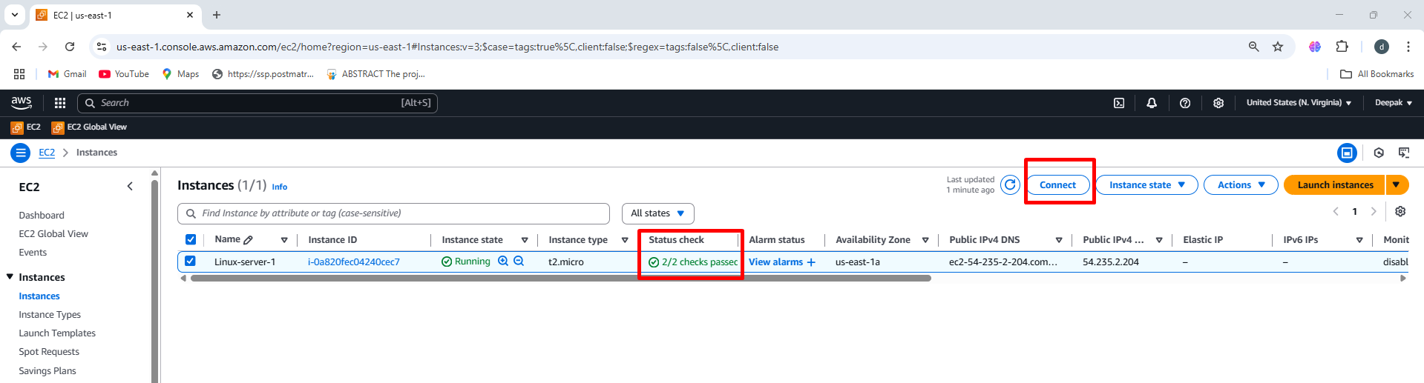

**Creating The Volume**

Navigating to the EC2 Dashboard, follow these steps to create an EBS Volume:

Volume 🡪 Create Volume 🡪 sizeof volume (5 GB) 🡪 Availability zone

(us-east-1a) 🡪 Create volume

**Step1:** In the left navigation panel, scroll down to **Elastic Block Store (EBS)**. 🡪 click on volumes

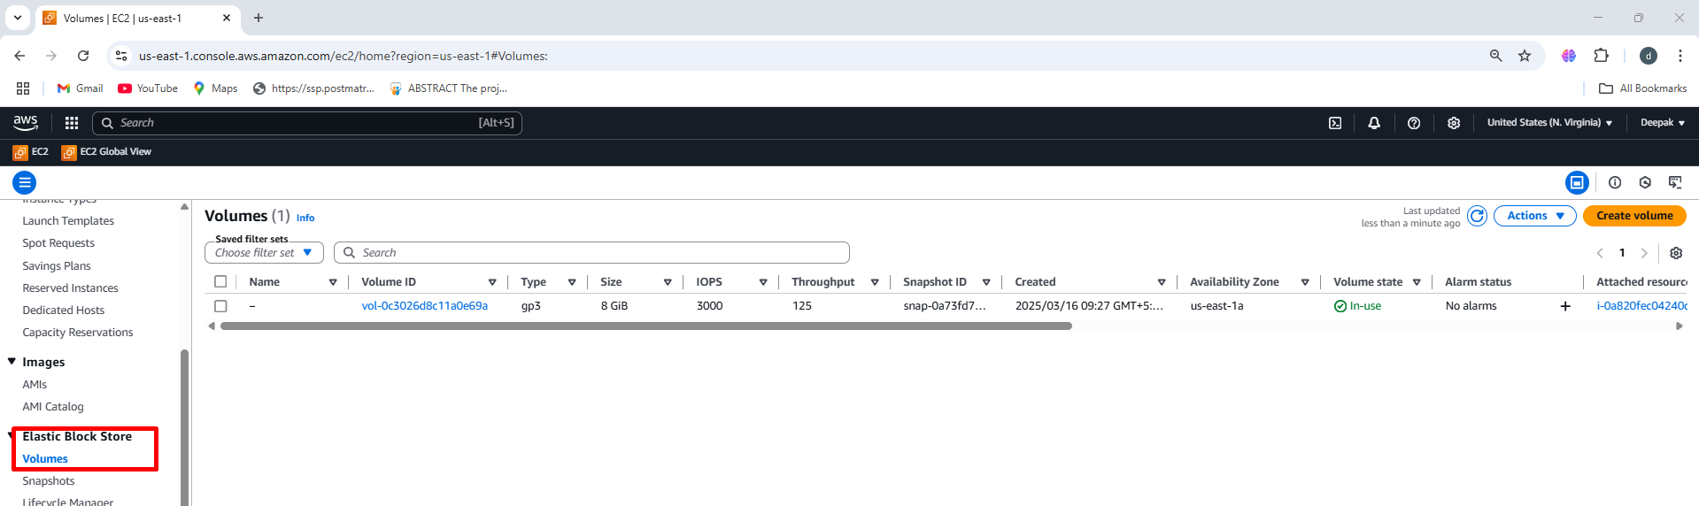

**Step2:** Create a New EBS Volume 🡪 Create a **New EBS Volume** 🡪 A **Create Volume form will appear.**

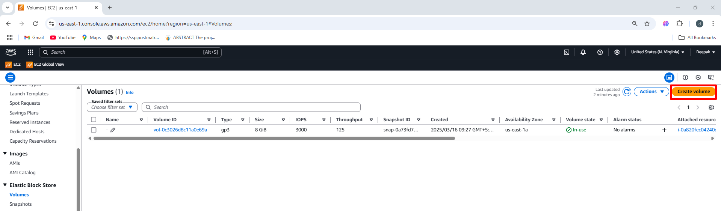

**Step3:** Configure the Volume 🡪 Enter **5 GiB as the storage capacity** 🡪 Select **us-east-1a** (Make sure it matches your EC2 instance's AZ) 🡪

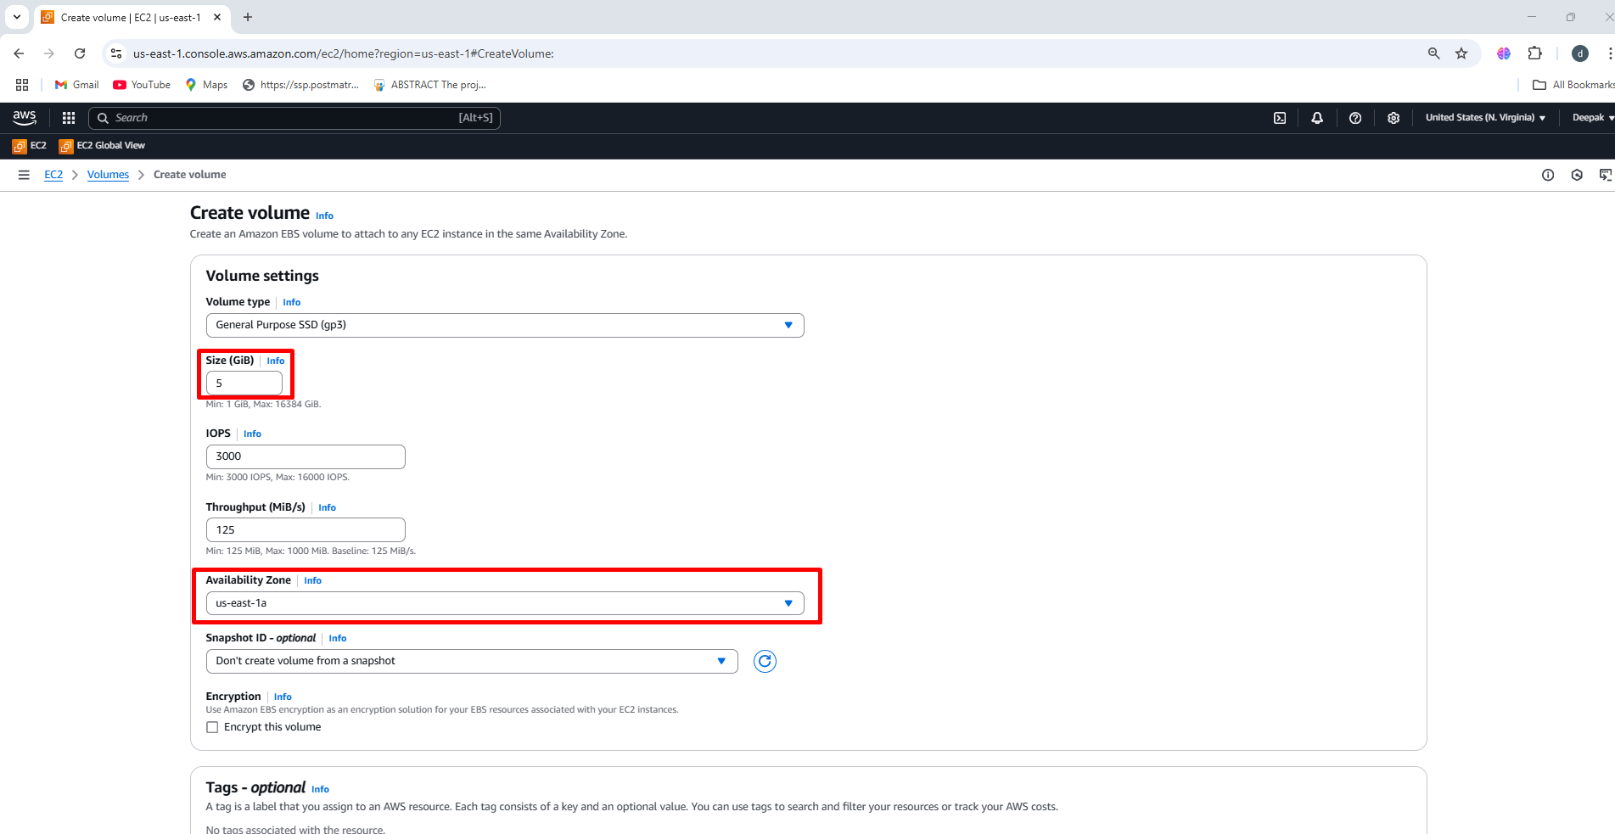

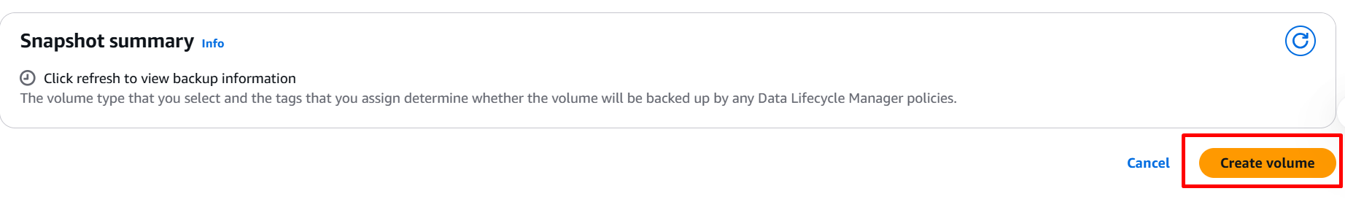

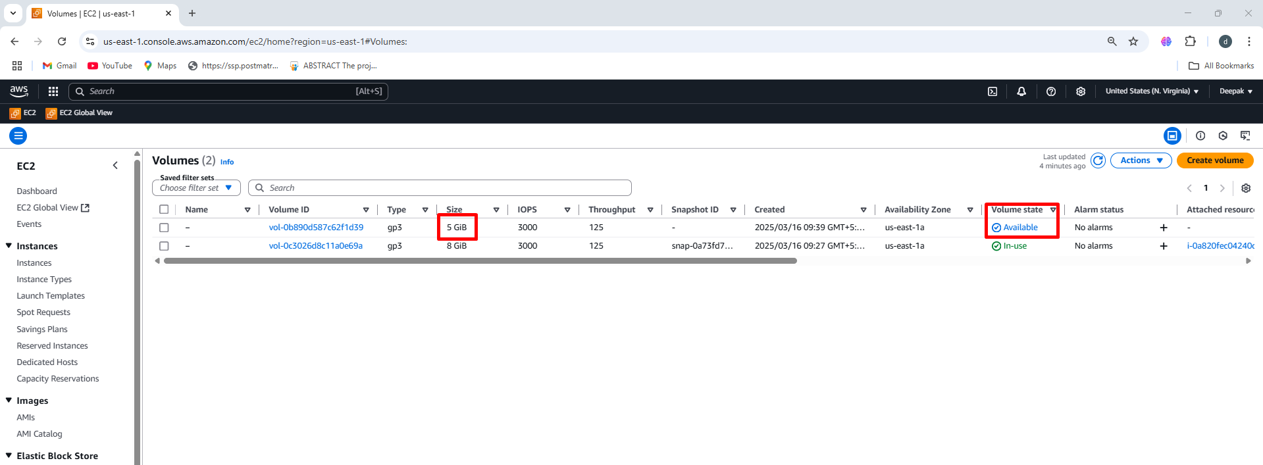

**Attaching Volume**

After creating the **EBS Volume**, the next step is to **attach it to an EC2 instance** in the same **Availability Zone (AZ)**.

Select volume 🡪  **Actions** 🡪 Attach volume 🡪 Select the instance 🡪

Device name 🡪 **xvd[f-p]** 🡪 Attach

**Step1: Attach the Volume to an EC2 Instance**

1. Select the EBS Volume 🡪 Click on the checkbox next to your volume.

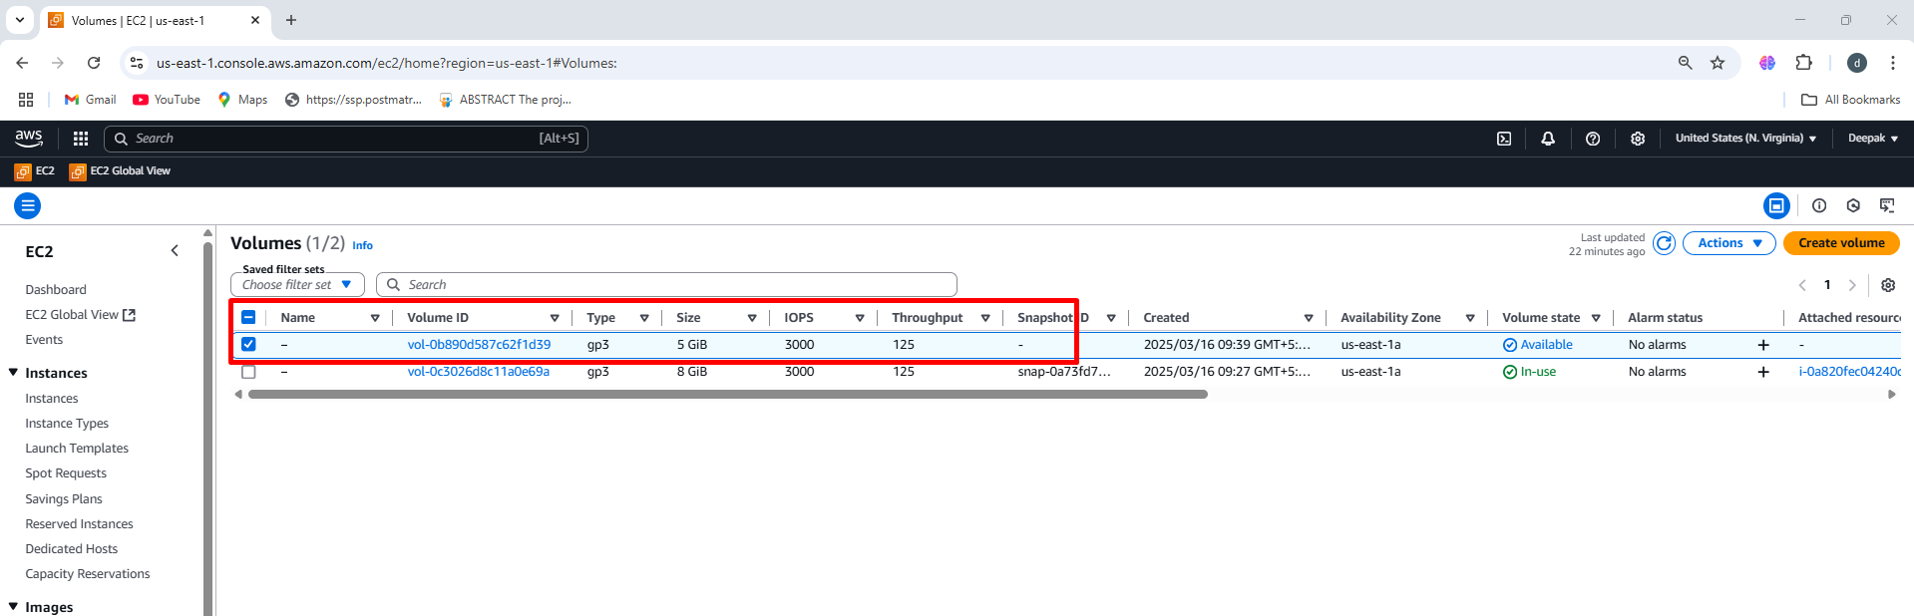

1. Click on Actions 🡪 At the top-right, click **Actions**  🡪 **Attach Volume.**

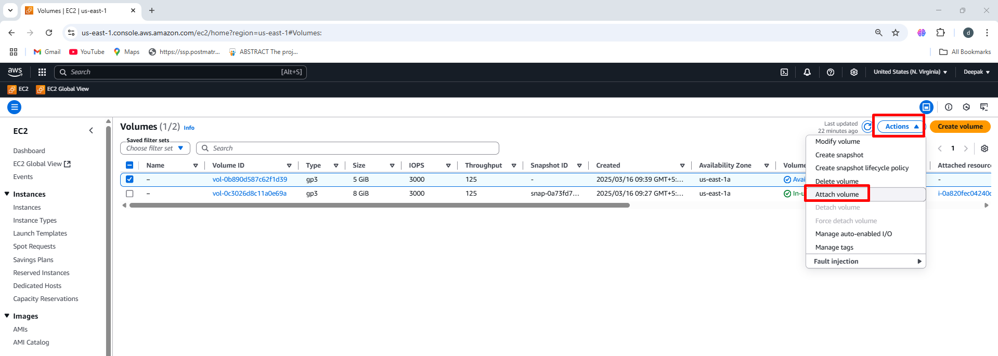

1. Select the EC2 Instance 🡪 In the Attach Volume window 🡪 Click the dropdown under Instance 🡪 Select the EC2 instance that is in the same Availability Zone (us-east-1a).

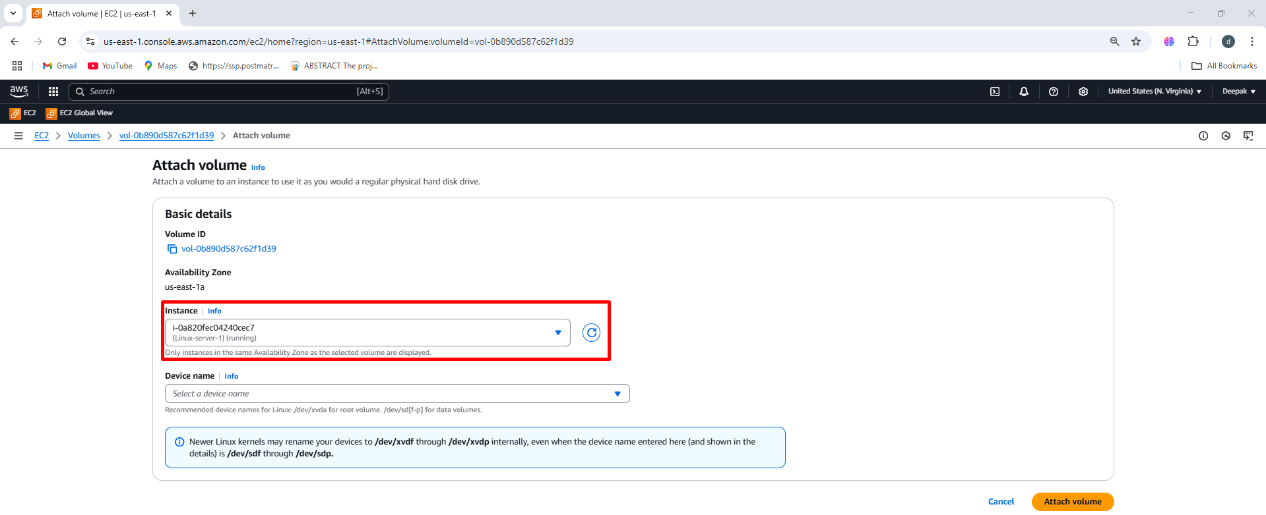

1. Specify Device Name 🡪 Enter the device name in Device Name field 🡪 Use xvd[f-p] (e.g., /dev/xvdf, etc.) 🡪 However, the Linux kernel may internally rename them as /dev/xvdf, /dev/xvdg, etc.

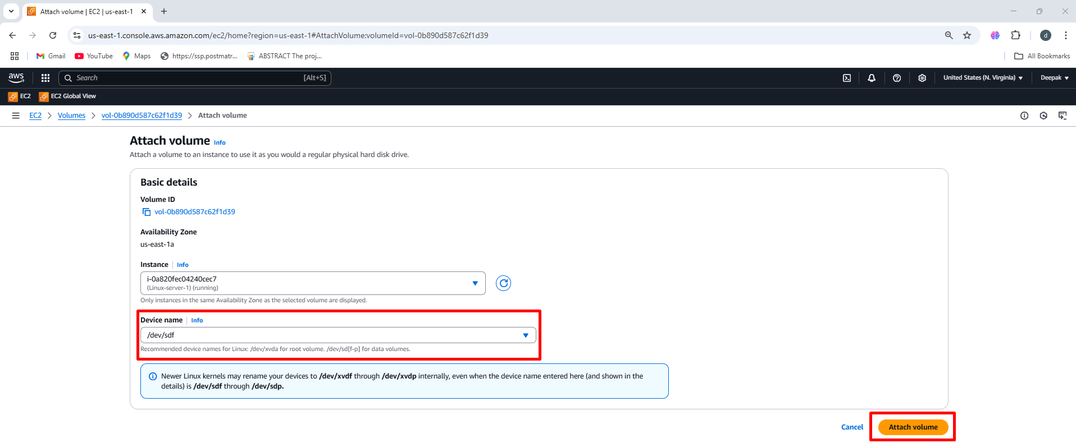

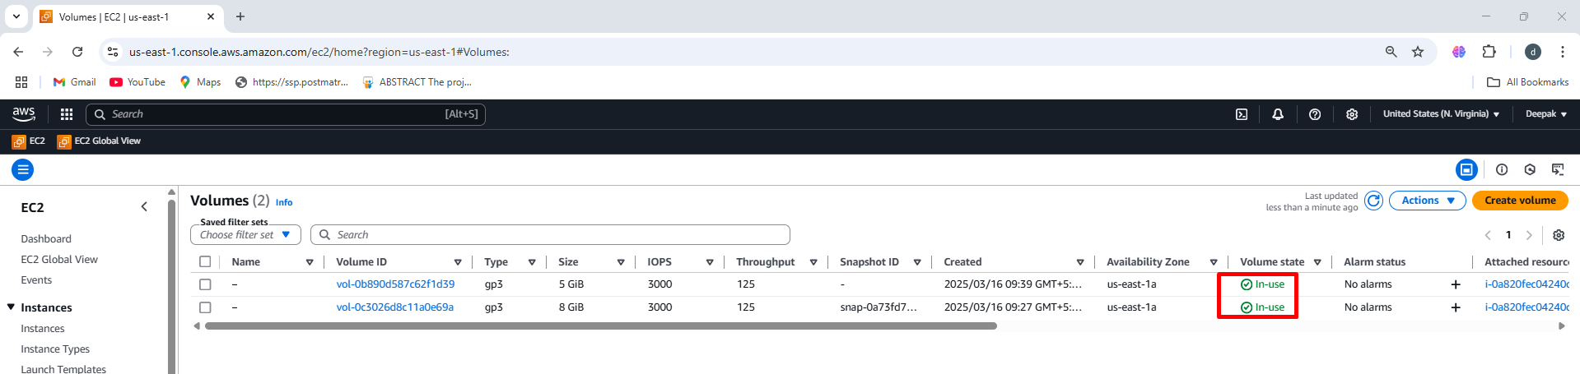

**Connecting to a Linux-1 EC2 Instance using Mobaxterm software**

MobaXterm is an **essential tool** for anyone working with **remote servers, networking, and automation**. It simplifies **remote access, file transfers, and development workflows** while providing **powerful terminal and networking capabilities**.

Launch **MobaXterm** on your Windows system. 🡪 Start a New SSH Session 🡪 Click on **"Session"** (top-left corner) 🡪 Select **"SSH"** from the session type 🡪 **Remote Host**: Enter the **IP address** or **hostname** of your Linux system 🡪 **Specify Username**: **Linux username (ec2-user)** 🡪 Advance ssh setting 🡪 Upload the **private key** (.pem) 🡪 Click on ok

**Step1:** Open Mobaxterm on your system 🡪 Below fig is Interface

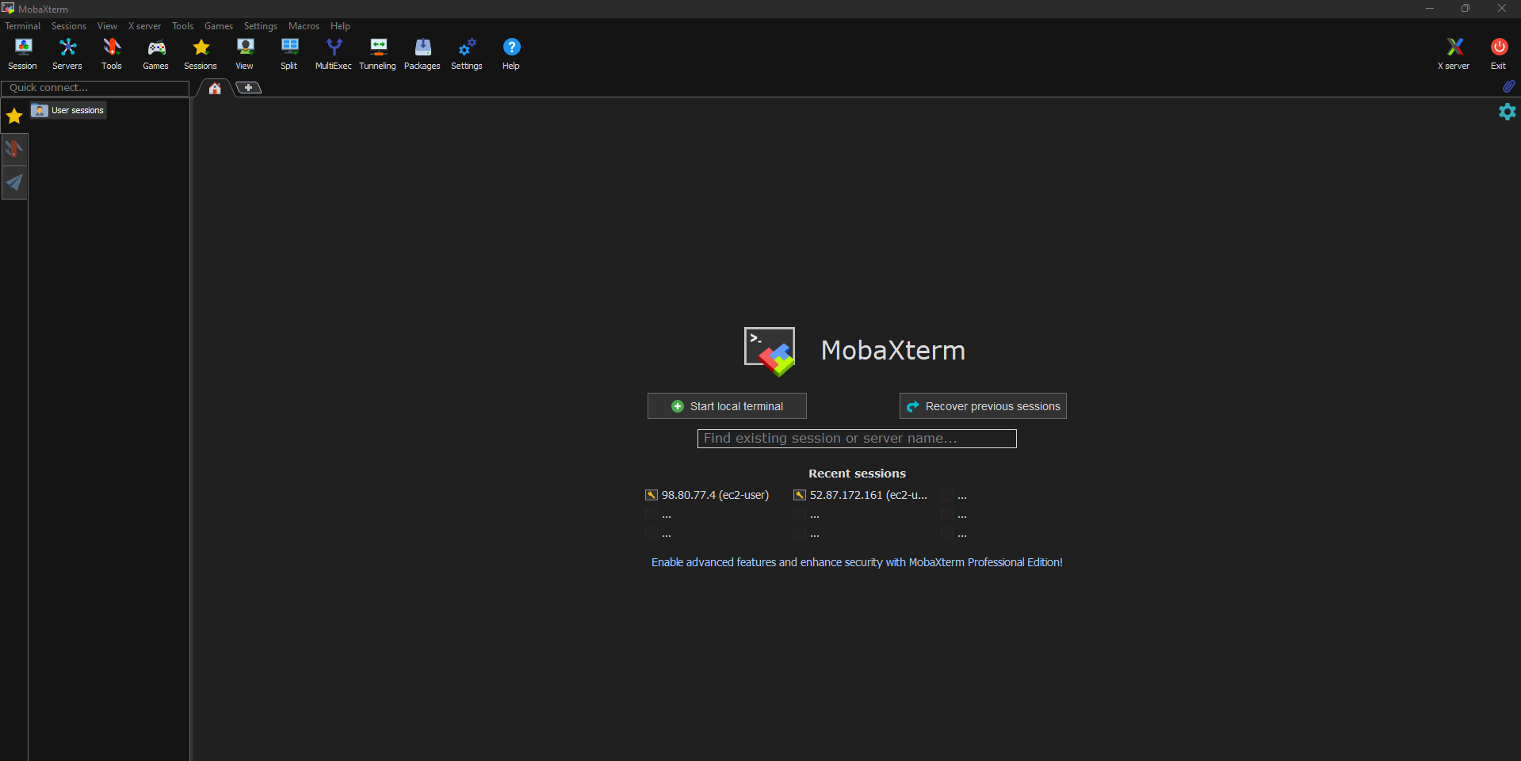

**Step2:** Start a New SSH Session 🡪 Click on **"Session"** (top-left corner) 🡪 Select **"SSH"** from the session type

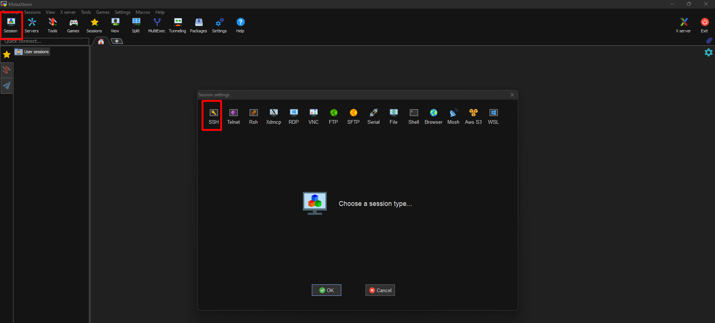

**Step2: Remote Host**: Enter the **IP address** or **hostname** of your Linux system 🡪 **Specify Username**: **Linux username (ec2-user)**

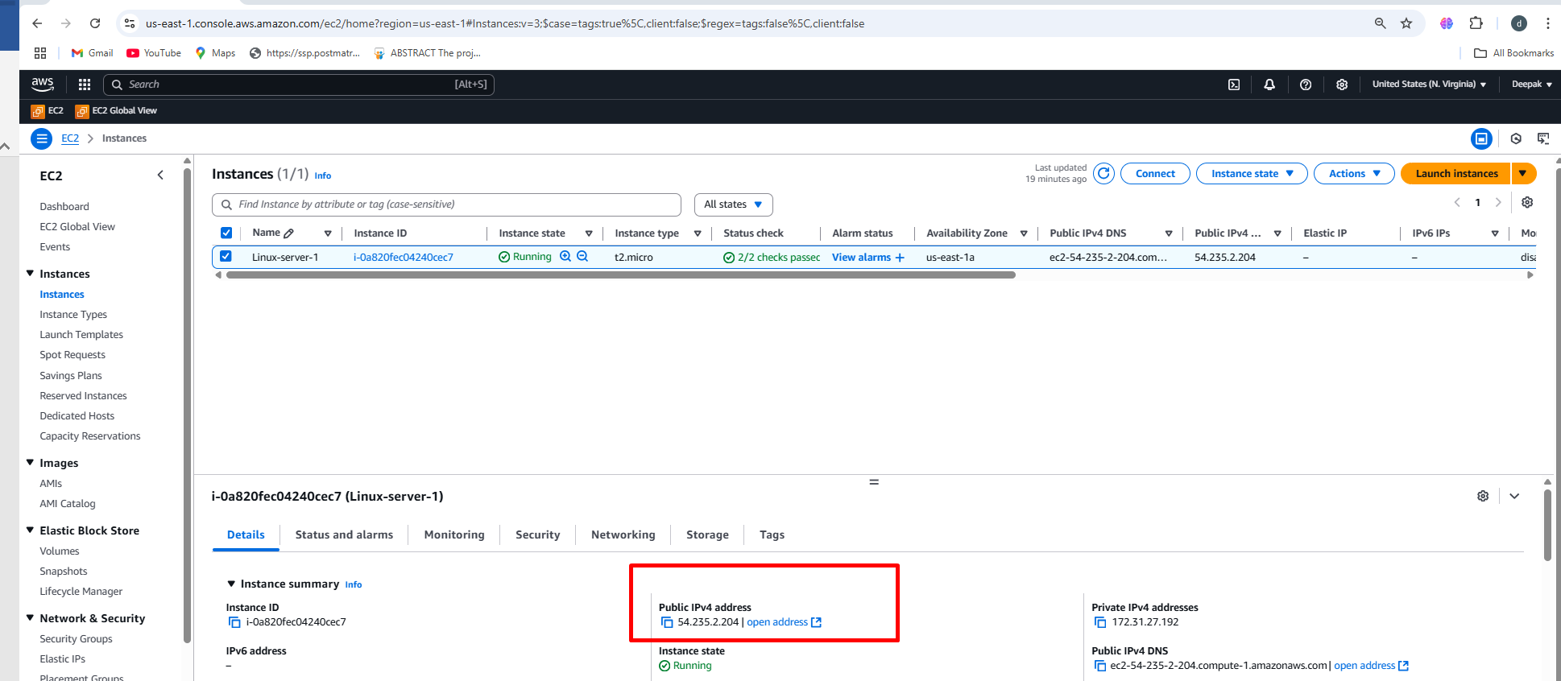

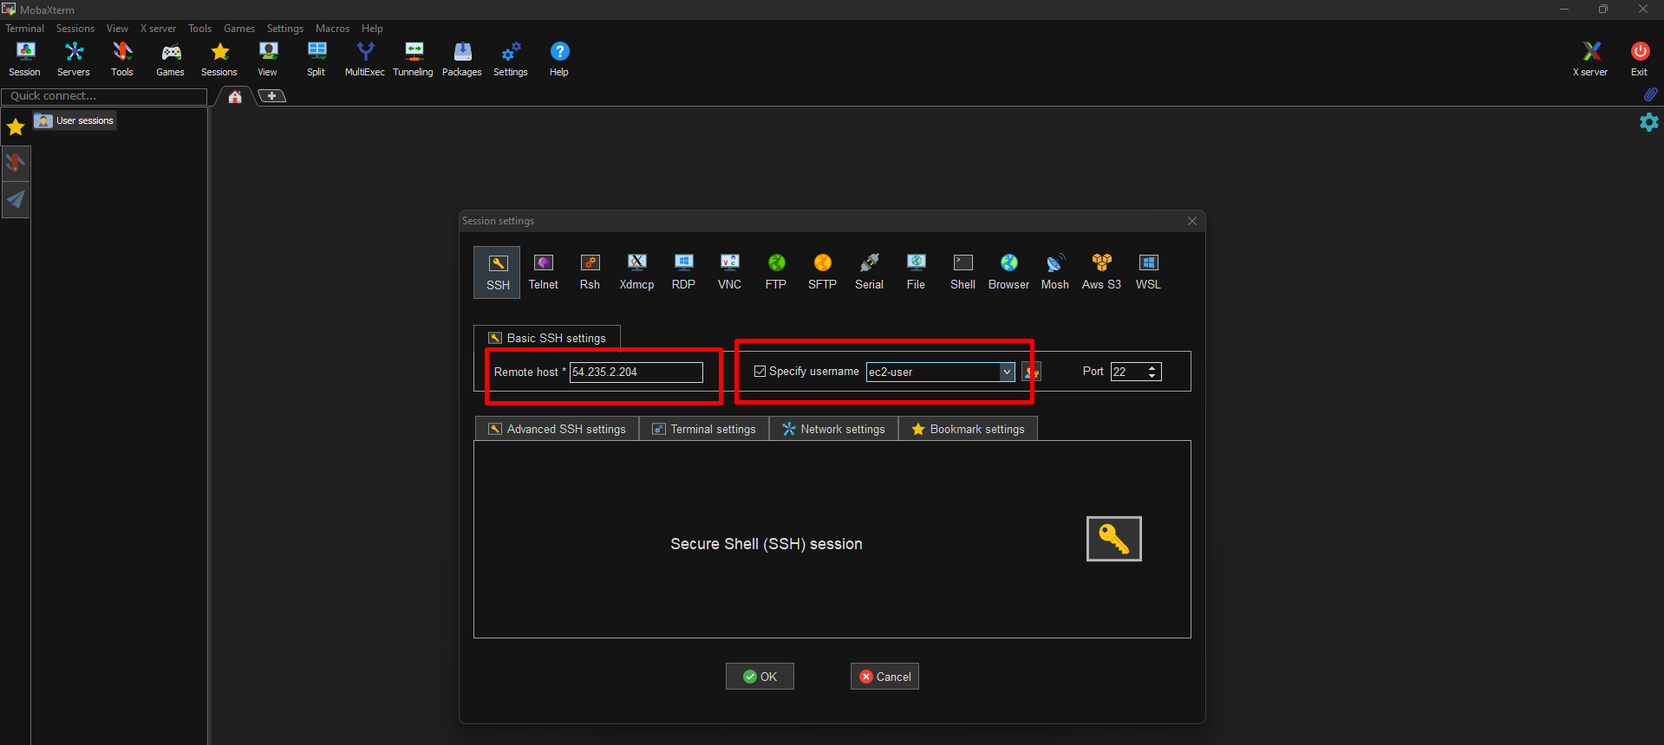

**Step3:** Advance ssh setting 🡪 Upload the **private key** (.pem) 🡪 Click on ok

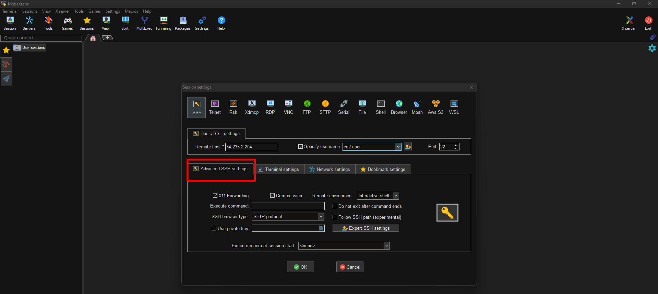

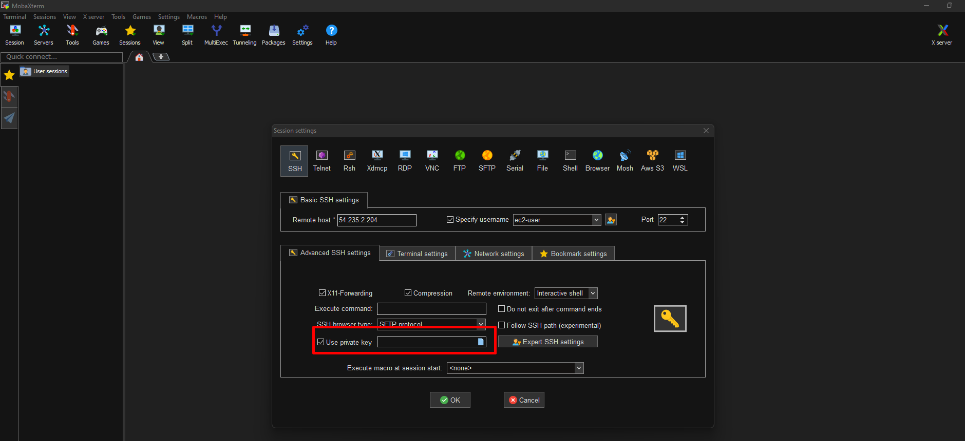

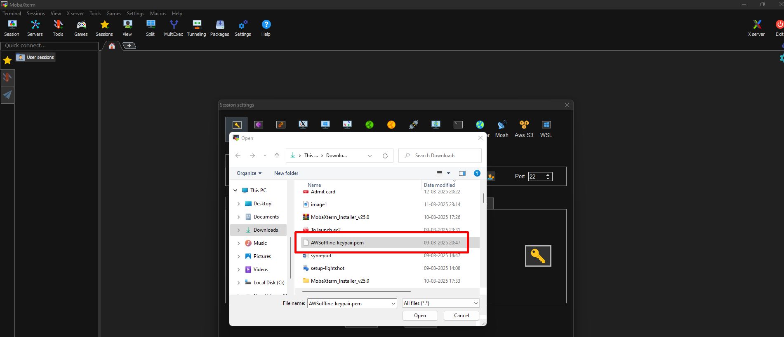

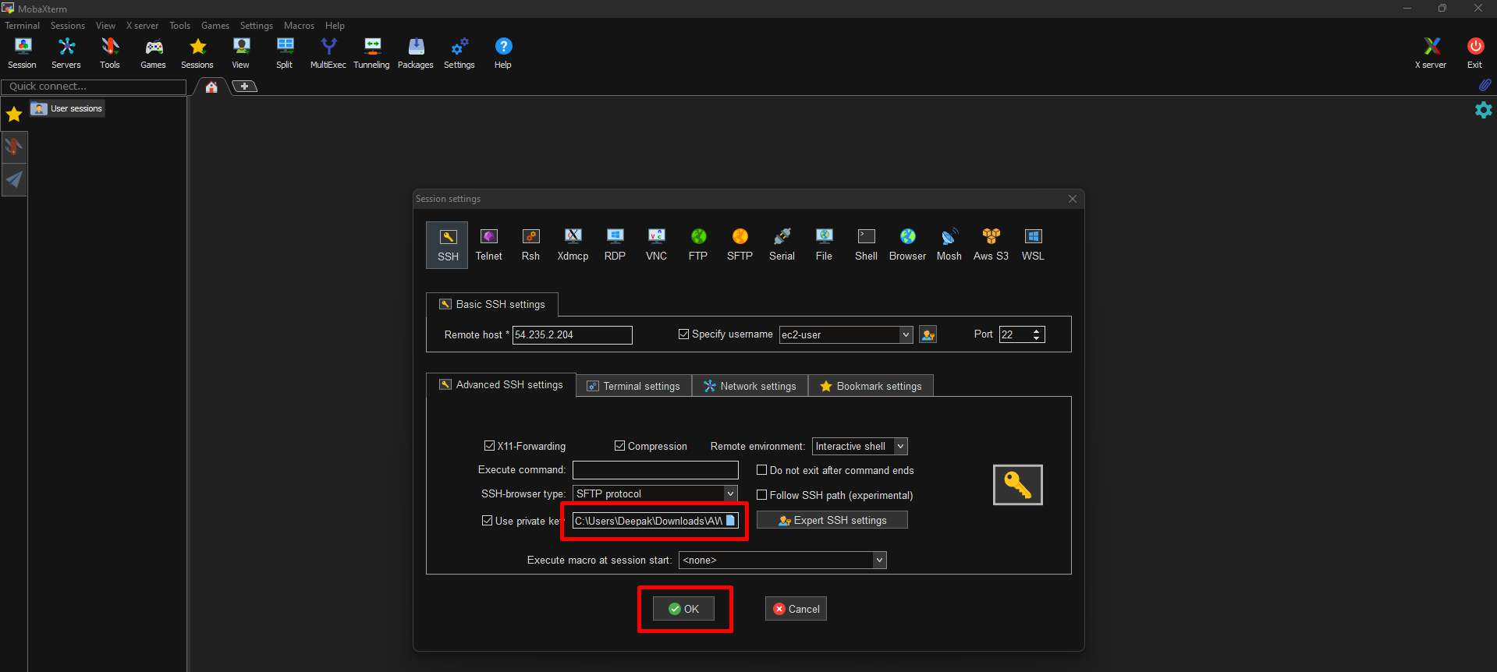

**Step4:** Accept the connection from remote server

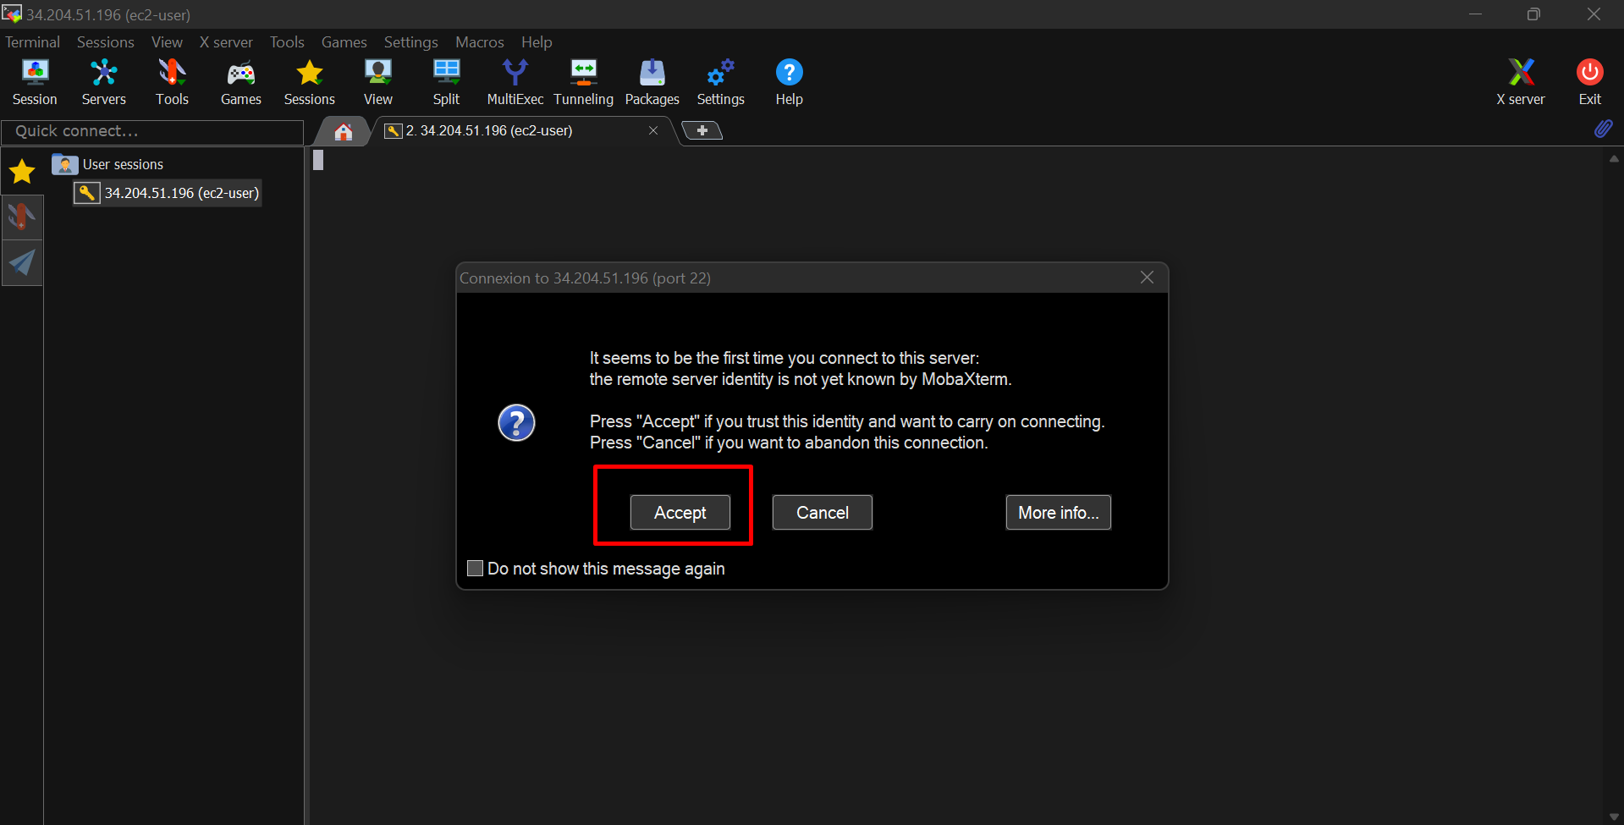

**CONNECTED TO VIRTUAL SERVERS**

**Step1:** Output screen of linux-server-1 which is connected through mobaxterm

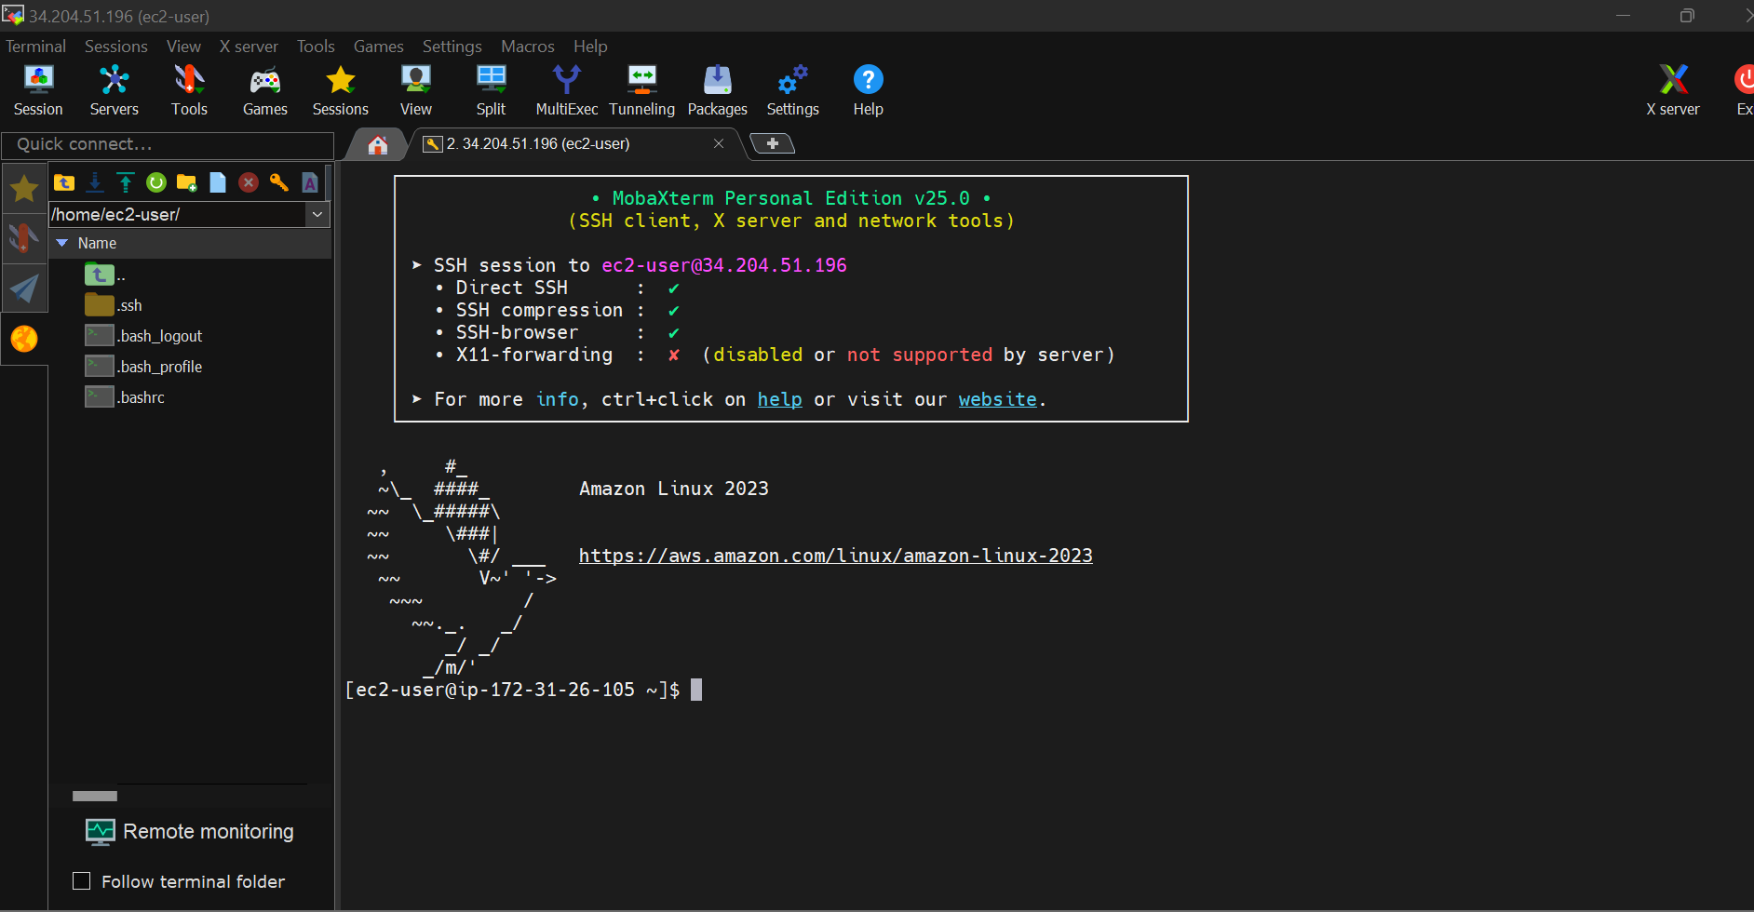

**Step2:** Check if the **Volume is Attached 🡪 lsblk**

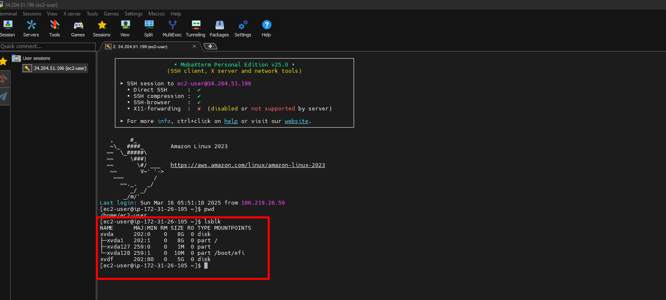

**Step3:** To check the volume format **🡪sudo file -s /dev/xvdf**

You will getdifferent outputs based on the state of the EBS volume 🡪 O/P is data This means the volume has no filesystem.

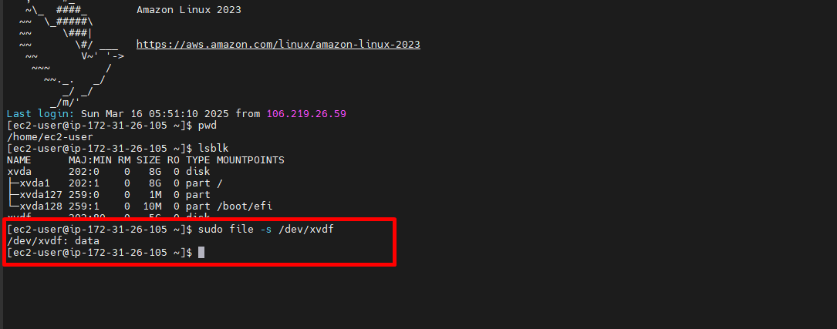

**Step4:** To format the volume 🡪 **sudo mkfs.ext4 /dev/xvdf**

This command erases all existing data on /dev/xvdf

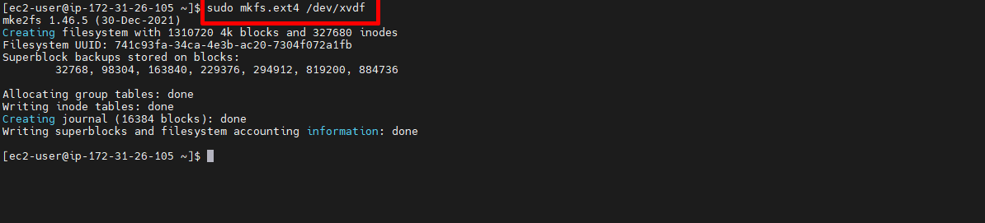

**Step5:** To display disk space 🡪 df -h

The df -h command is used to display the disk space usage of filesystems in a human-readable format.

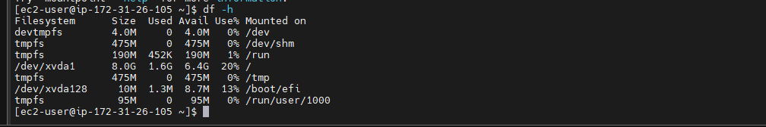

**Step6:** Create a directory Volume-d 🡪 mkdir volume-d

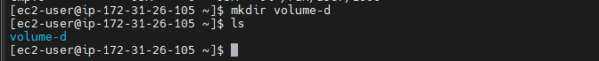

**Step7:** To check the mountpoint 🡪 **mountpoint volume-d**

Checking whether a directory is a mount point ensures that a disk or partition is properly mounted before performing operations like reading/writing data, backups, or system administration tasks.

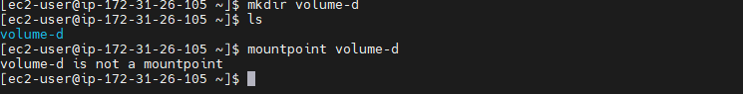

**Step8:** To connect the EBS volume to directory 🡪 **sudo** **mount /dev/xvdf volume-d**

Now volume-d is a mountpoint

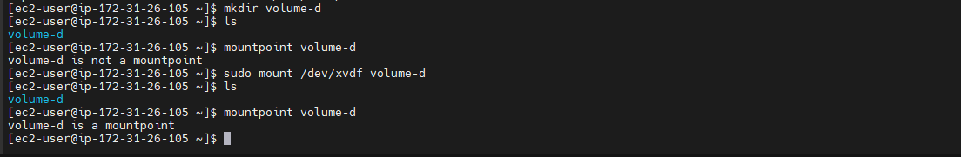

**Step9:** Change directory to volume-d 🡪 **cd volume-d**

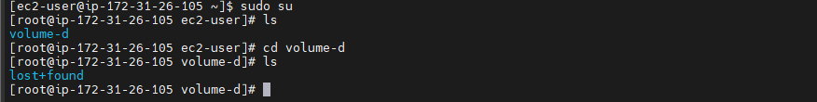

**Step10:** Create dir1 in volume-4 🡪 **mkdir dir1**

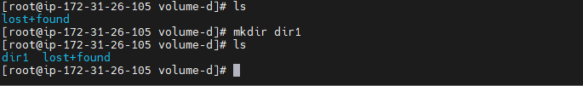

**Step11:** Change directory to dir1🡪 **cd dir1** 🡪 Create a text file or html file inside the dir1

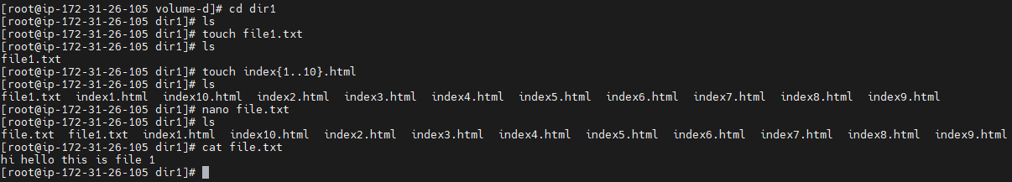

**Step12:** Exit from directory to ec2-user 🡪 umount volume-d

To ensures safe removal of a storage device (disk, USB, network share) before detaching or modifying it

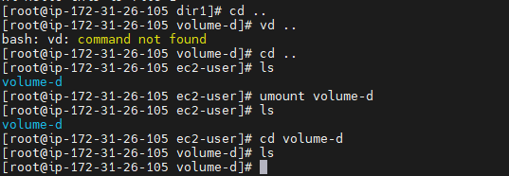

**Step13:** Select actions in volume and **detach** ,to attach for other availability zone

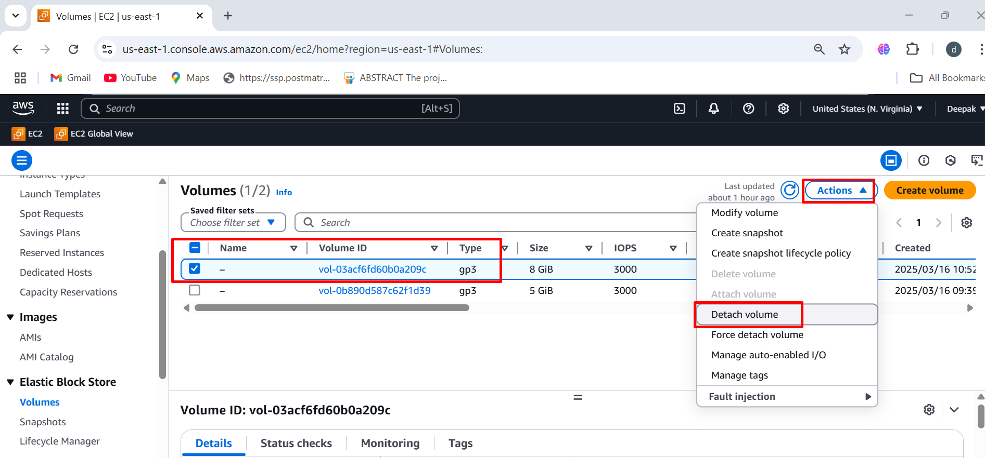

**Step13:** Volume is available not **in-use, now we can attach to other availability zone**

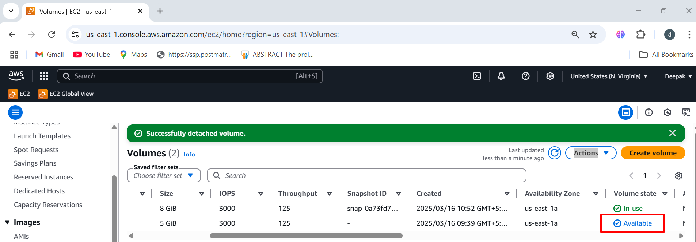

**We need to create same availability zone on linux-server-2**

To launch Instance follow the same steps which we created in Linux-server-1

**Step1:** Creating same availability zone on linux-server-2 (us-east-1a)

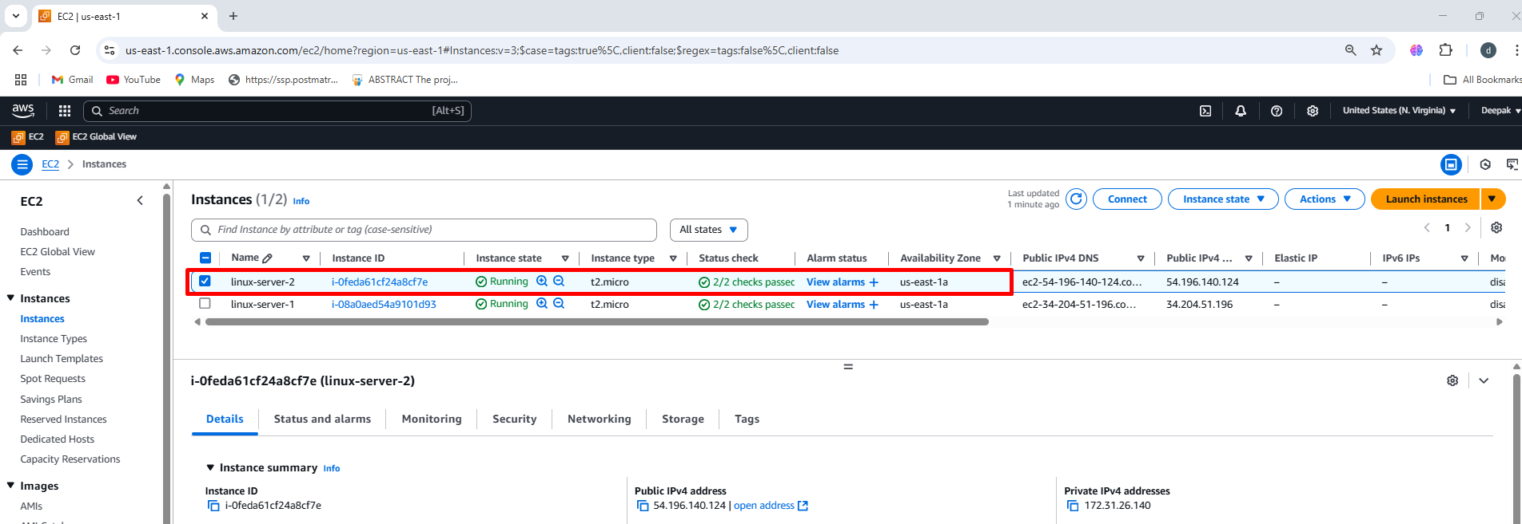

**Step2:** Attach the volume to linux-server-2 (us-east-1a)

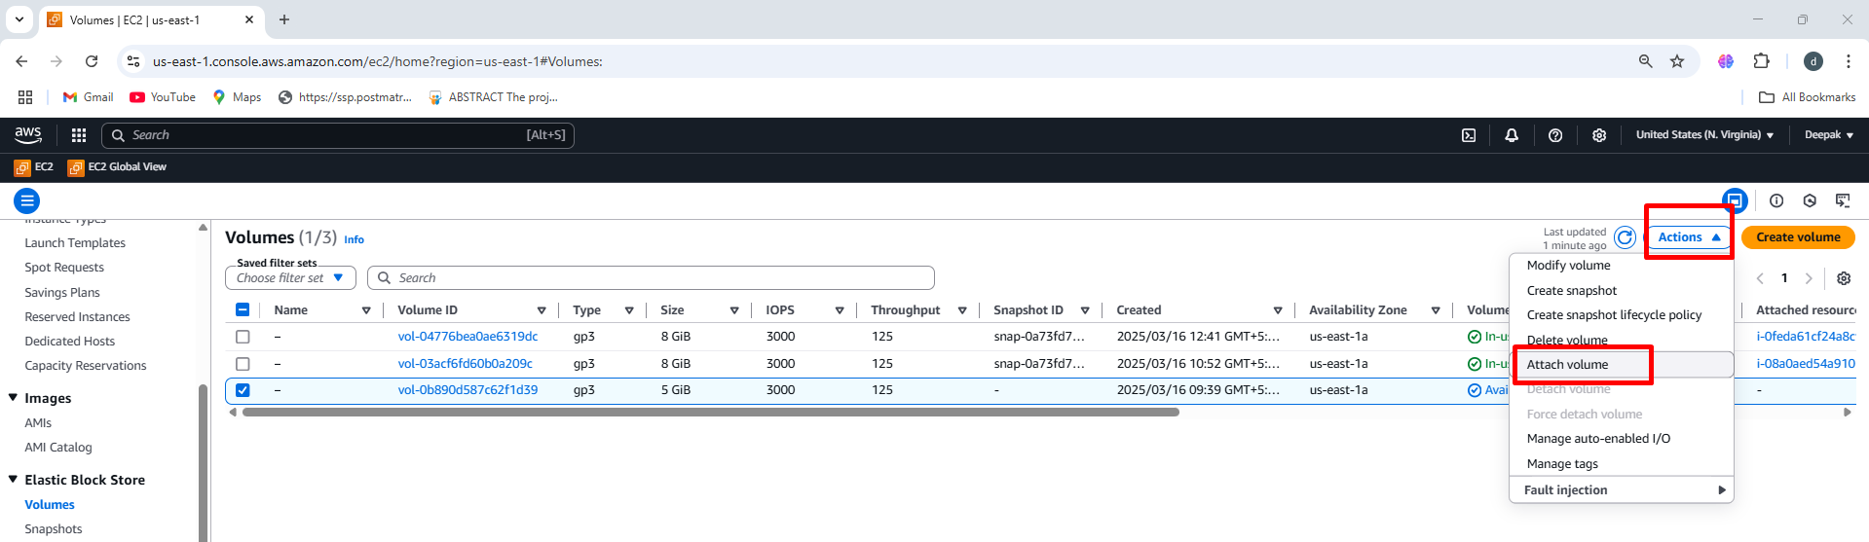

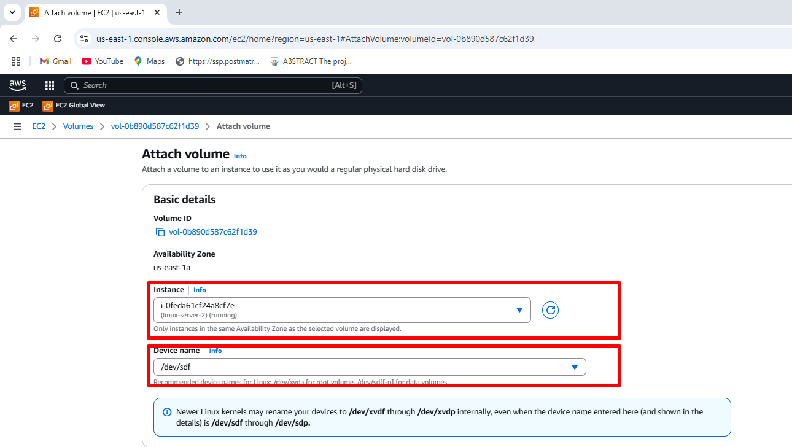

**Step3:** Click on the attach volume

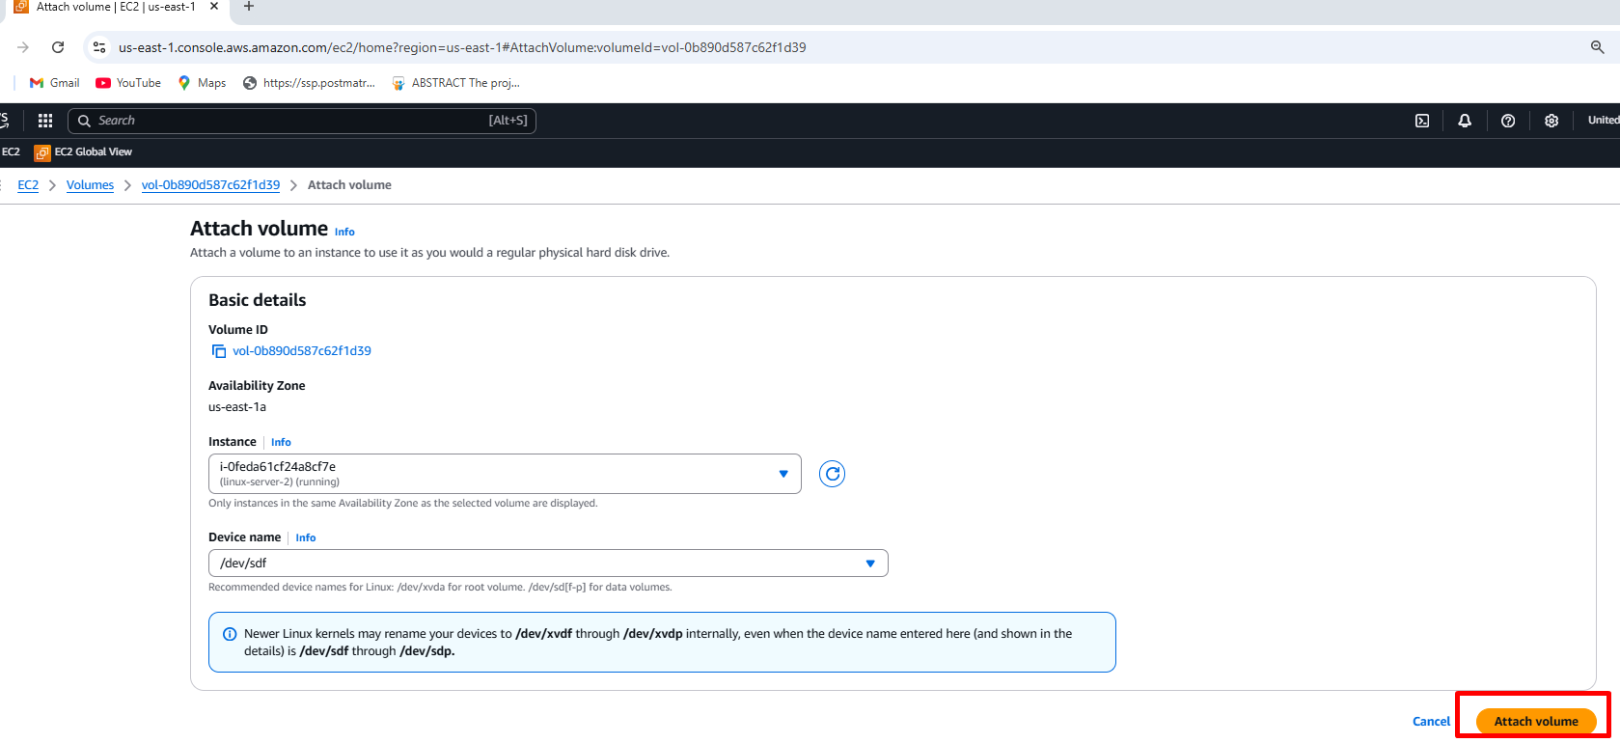

**Step4:** Follow the same step to connect the mobaXterm in linux-server-1 🡪 below image is a output screen of linux-server-2 Which is connected through mobaxterm

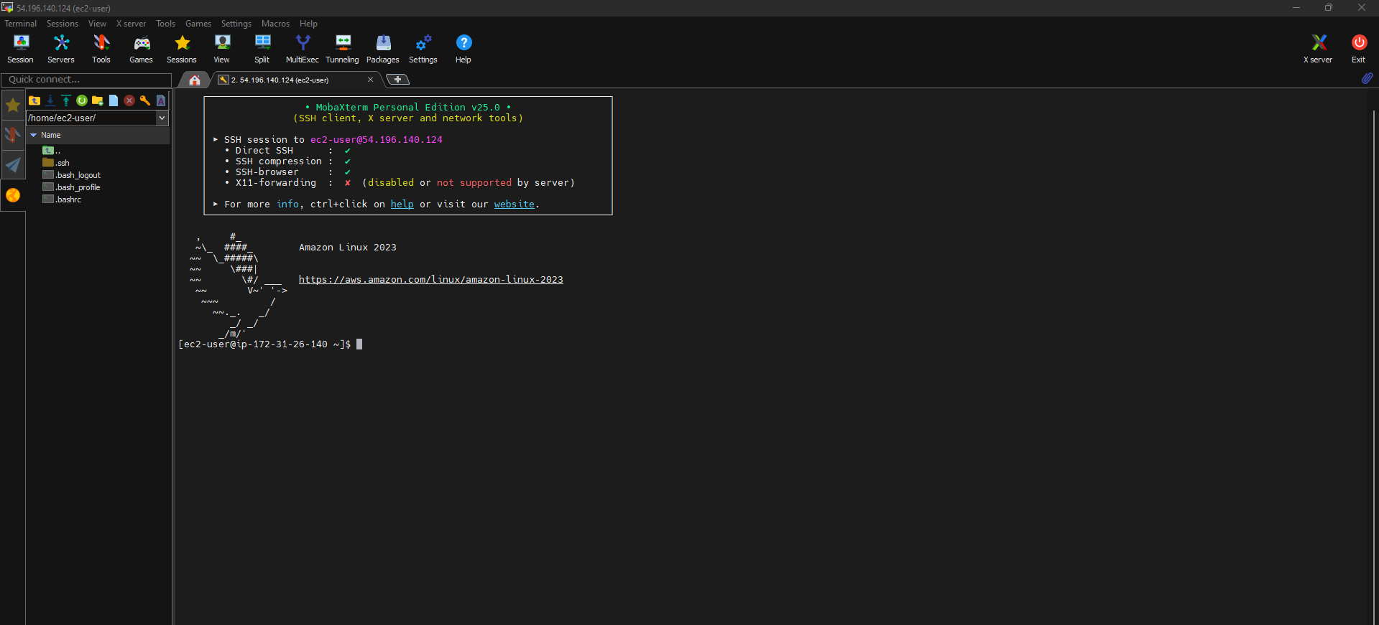

**Step5:** Check if the **Volume is Attached 🡪 lsblk**

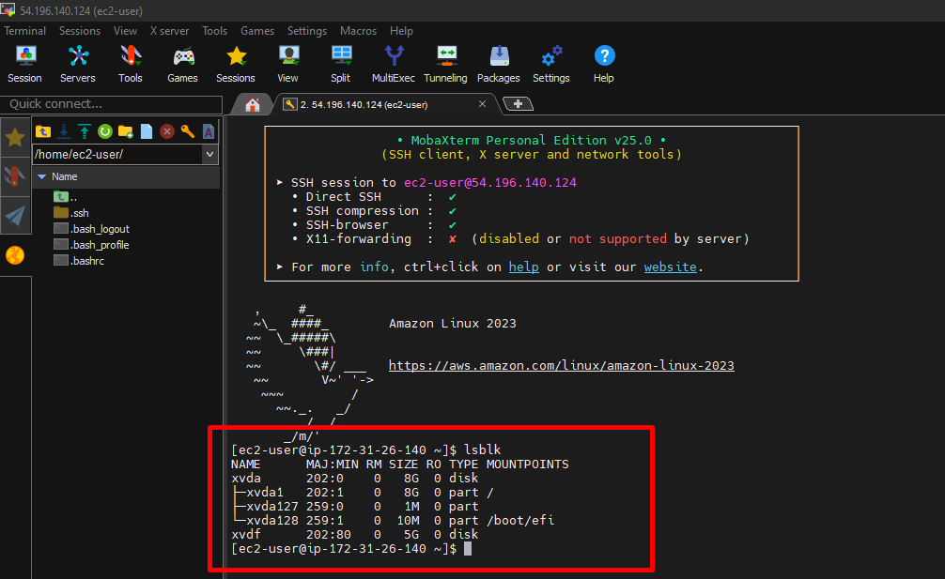

**Step6:** To check the volume format **🡪sudo file -s /dev/xvdf**

**The below image shows attached volume filesystem data**

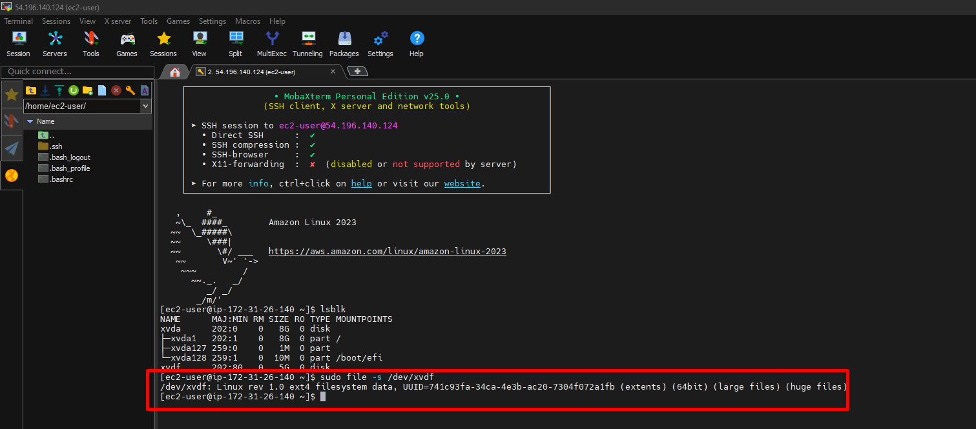

**Step7:** Create a directory Volume-E 🡪 mkdir volume-E

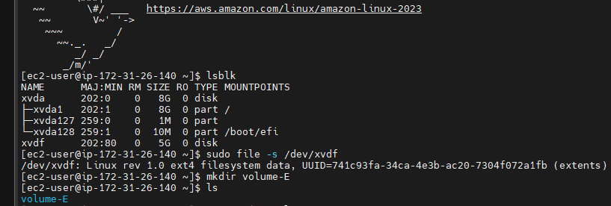

**Step8:** To check the mountpoint 🡪 **mountpoint volume-E**

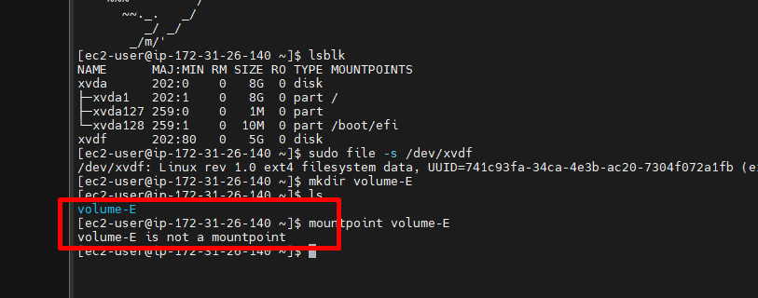

**Step9:** To connect the EBS volume to directory 🡪 **sudo** **mount /dev/xvdf volume-E**

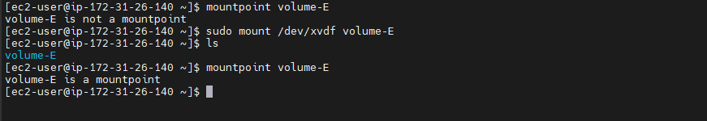

**Step10:** Change directory to volume-d 🡪 **cd volume-E 🡪 attached volume data as found**

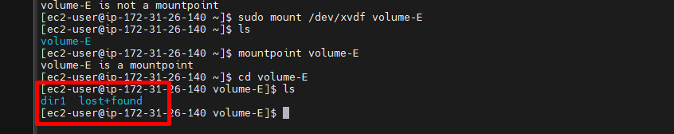

**Step11:** Change directory to dir1 🡪 **cd dir1 🡪 attached volume data as found**

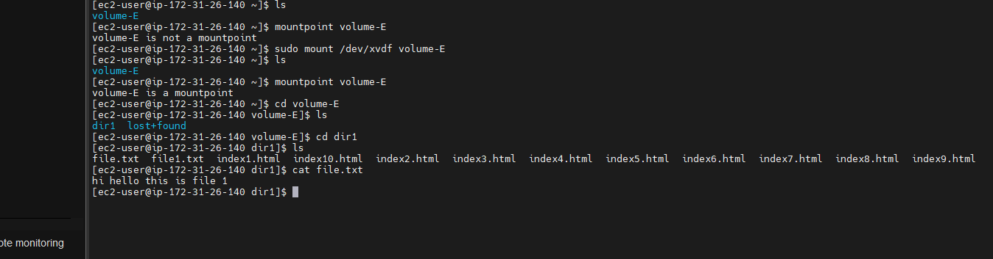

**Step12:** Now create movies folder in volume-E 🡪 Add the data inside the movies 🡪 exit from directory 🡪 umount Volume-E

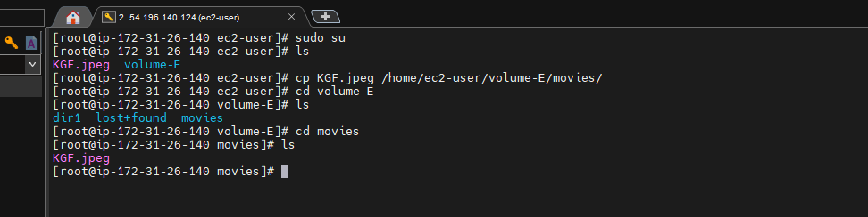

**Step13:** Exit from directory to ec2-user 🡪 umount volume-E

To ensures safe removal of a storage device (disk, USB, network share) before detaching or modifying it

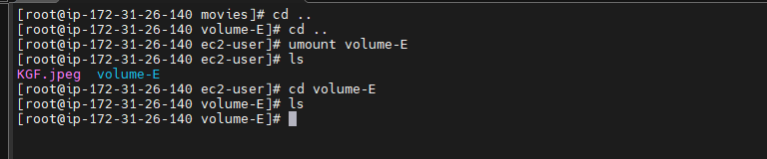

**Step14:** Select actions in volume and **detach** ,to attach for other availability zone

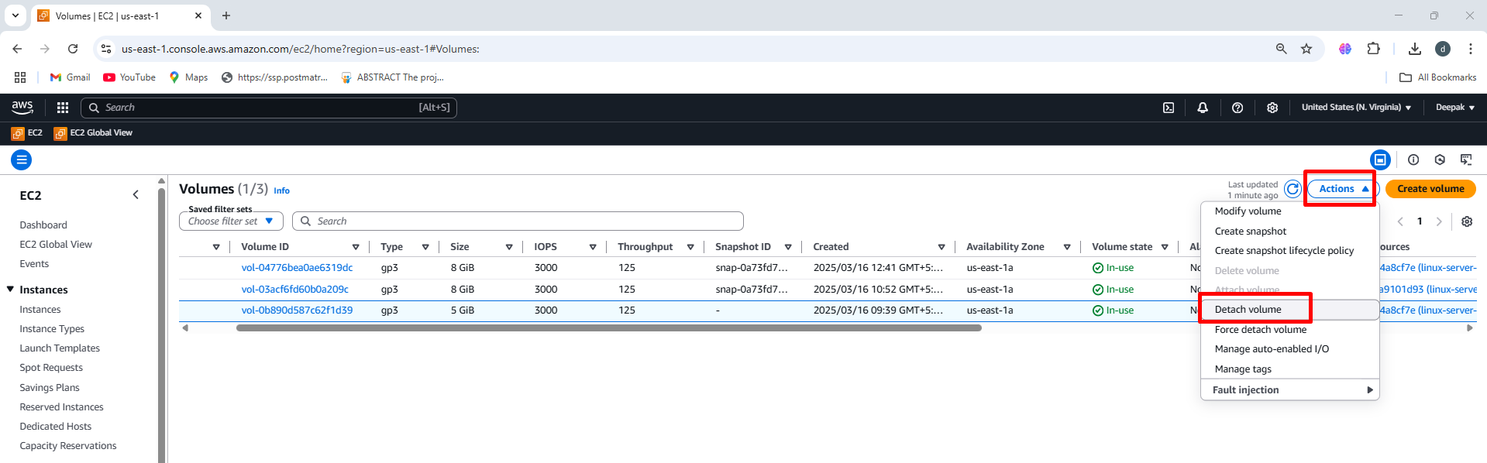

**Step15:** Volume is available not **in-use, now we can attach to other availability zone**

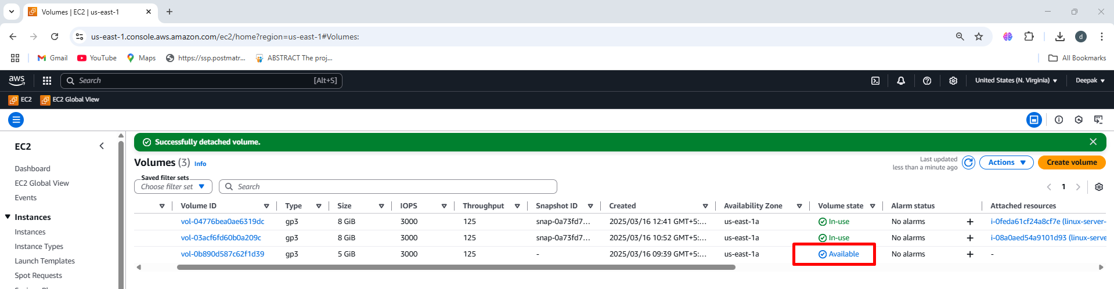

To connect an **EBS (Elastic Block Store)** volume to an **EC2 instance** **within the different availability zone**, follow these steps:

To launch Instance follow the same steps which we created in same availability zone, here need to create different availability zone

**We need to create same availability zone on linux-server-3**

**Step1:** Creating different availability zone on linux-server-3 (us-east-1c)

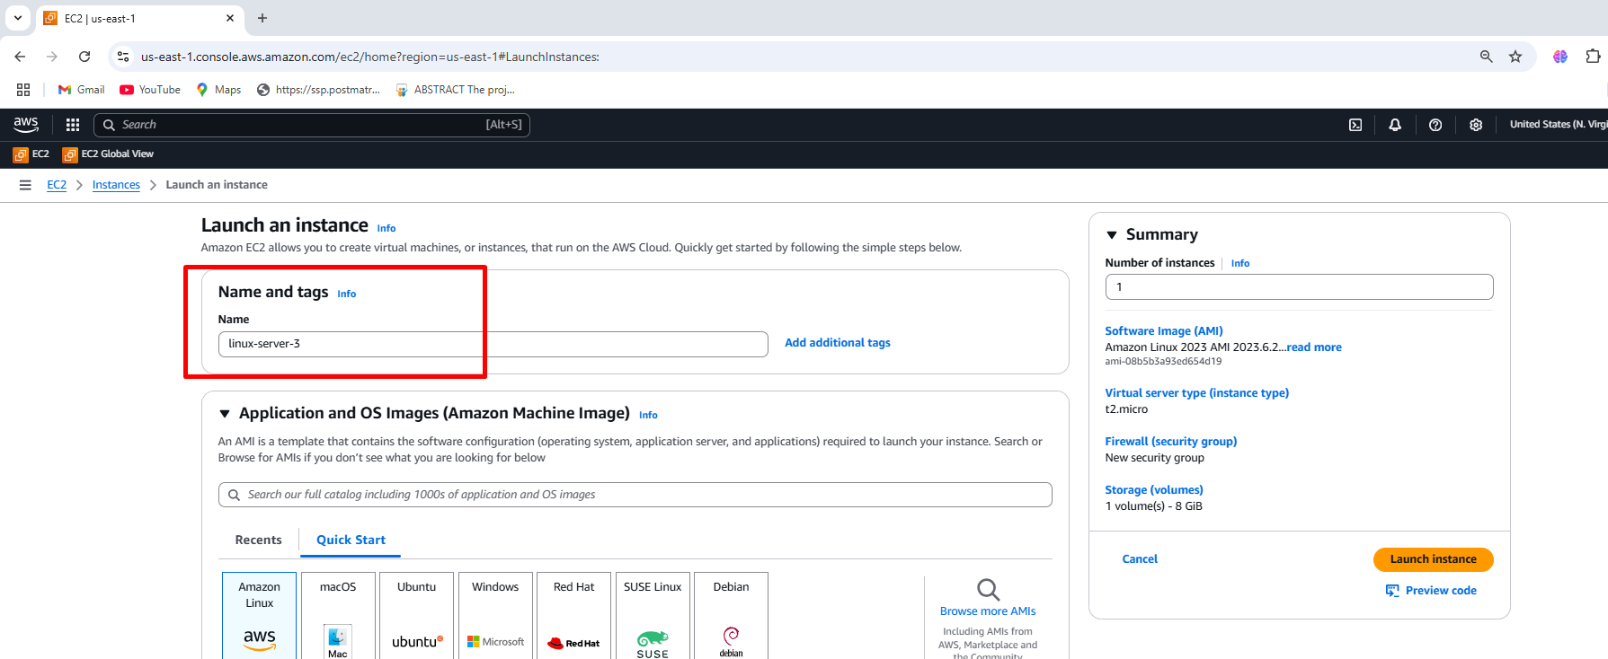

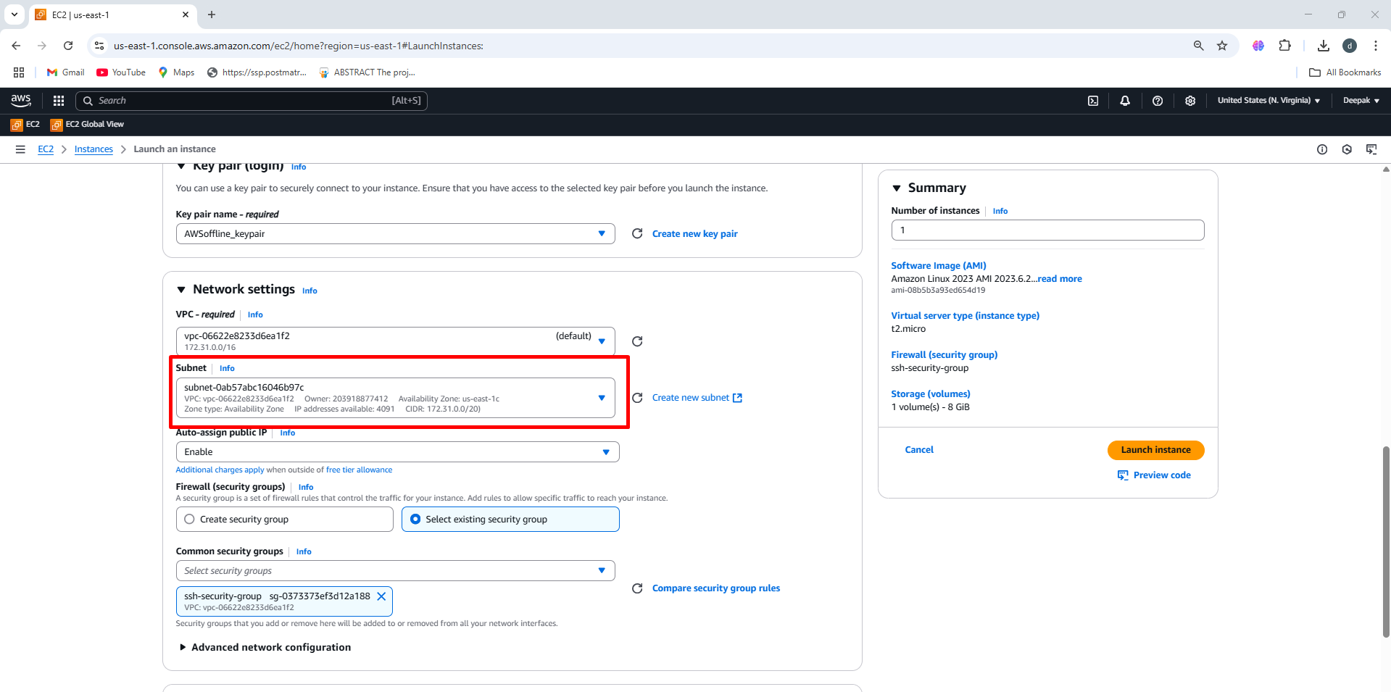

**Step2:** After creating linux-server-3 in (us-east-1c) check for 2/2 status

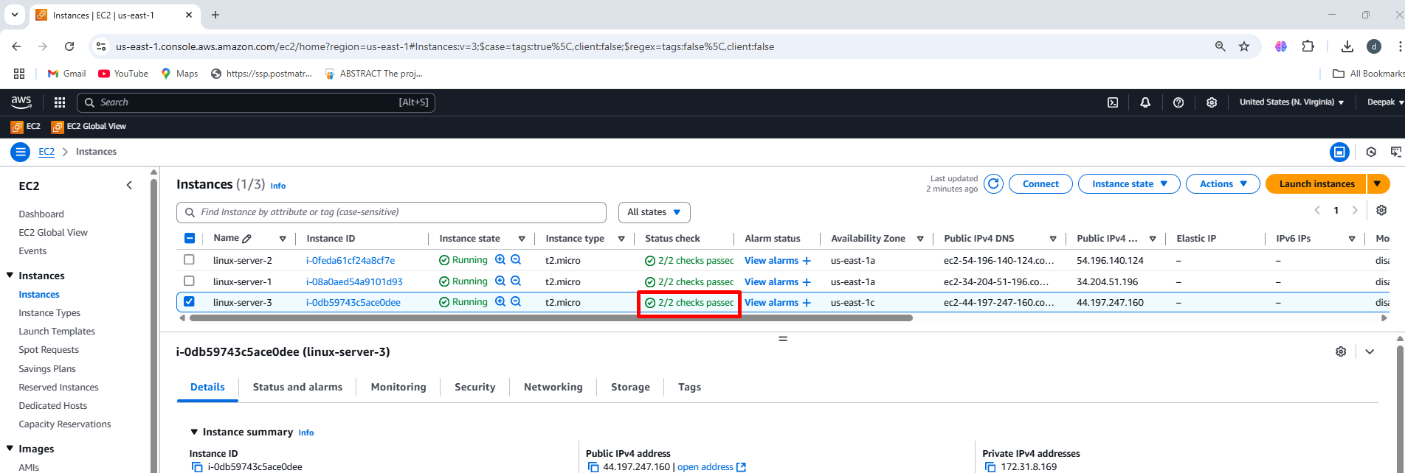

**Step3:** When the volume state is available ,Then create snapshot

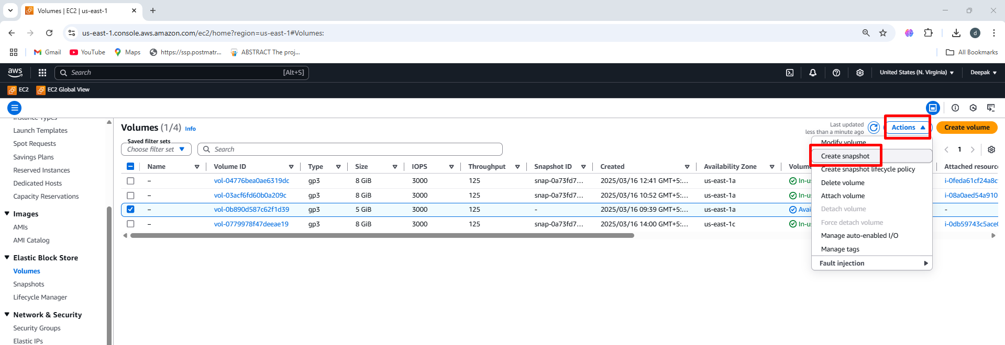

**Step4:** Provide the snapshot details 🡪 create snapshot

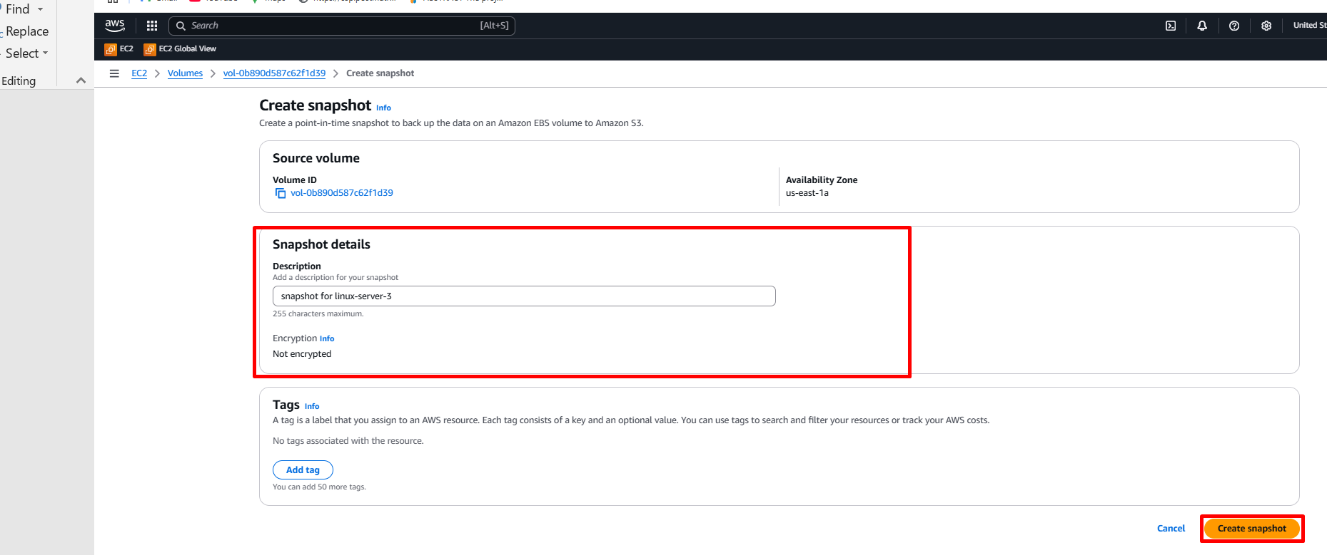

**Step5:**  Click on snapshot, once the status is completed, click on create

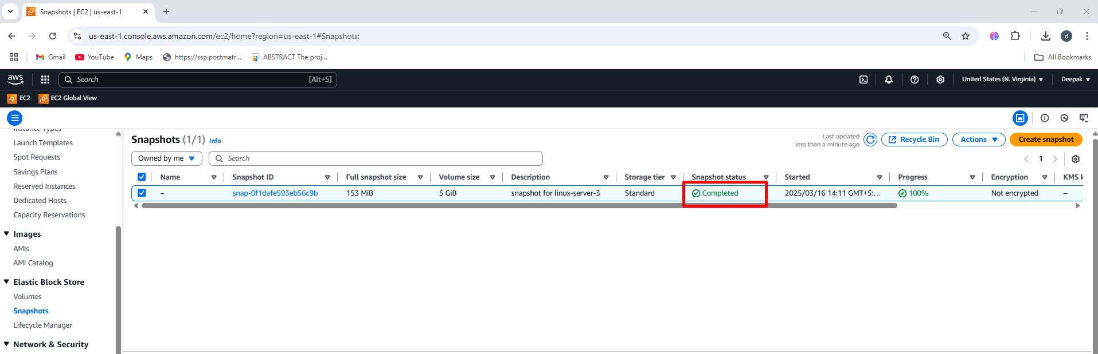

**Step6:** Then Click on action 🡪 Click on create volume from snapshot

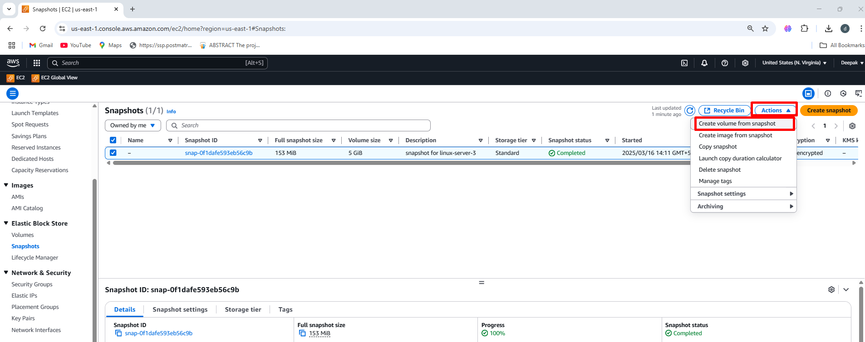

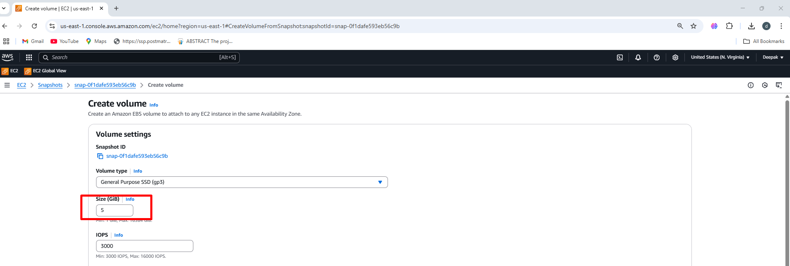

**Step7: Select the different availability zone (us-east-1c) 🡪 Create volume**

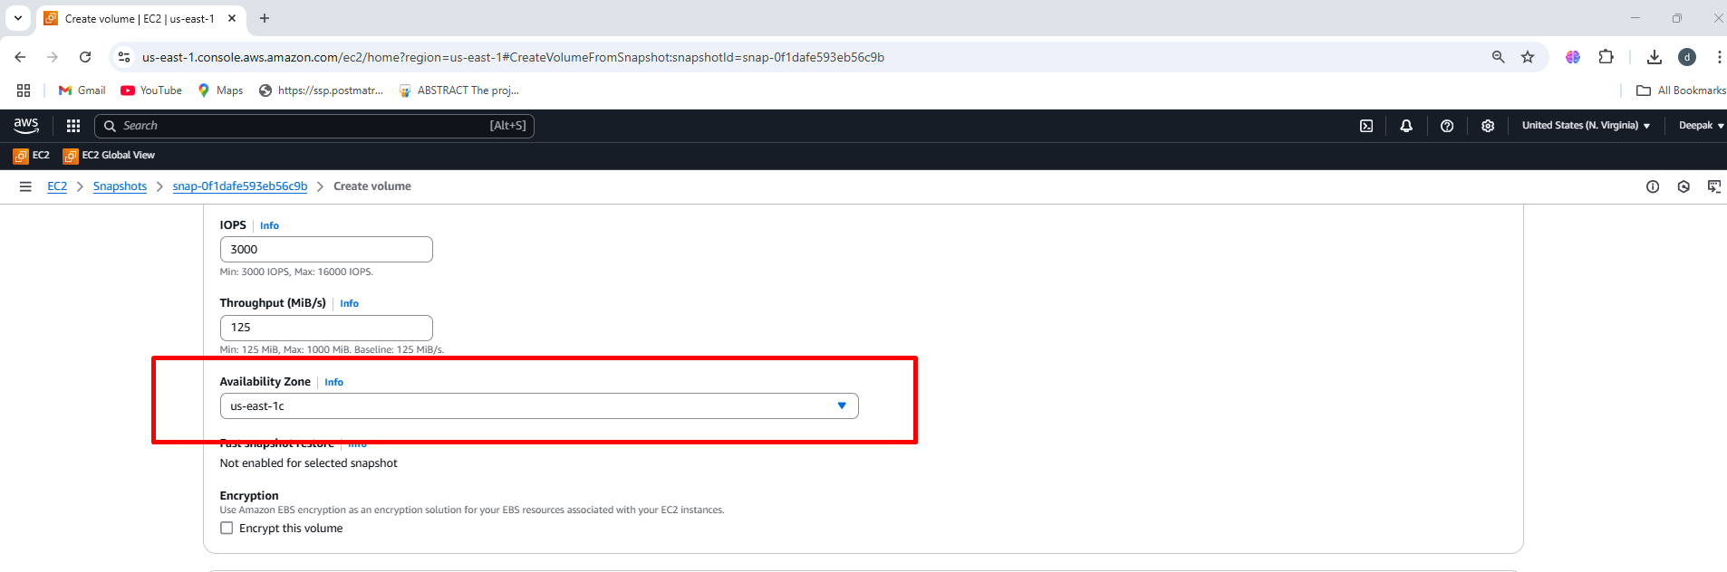

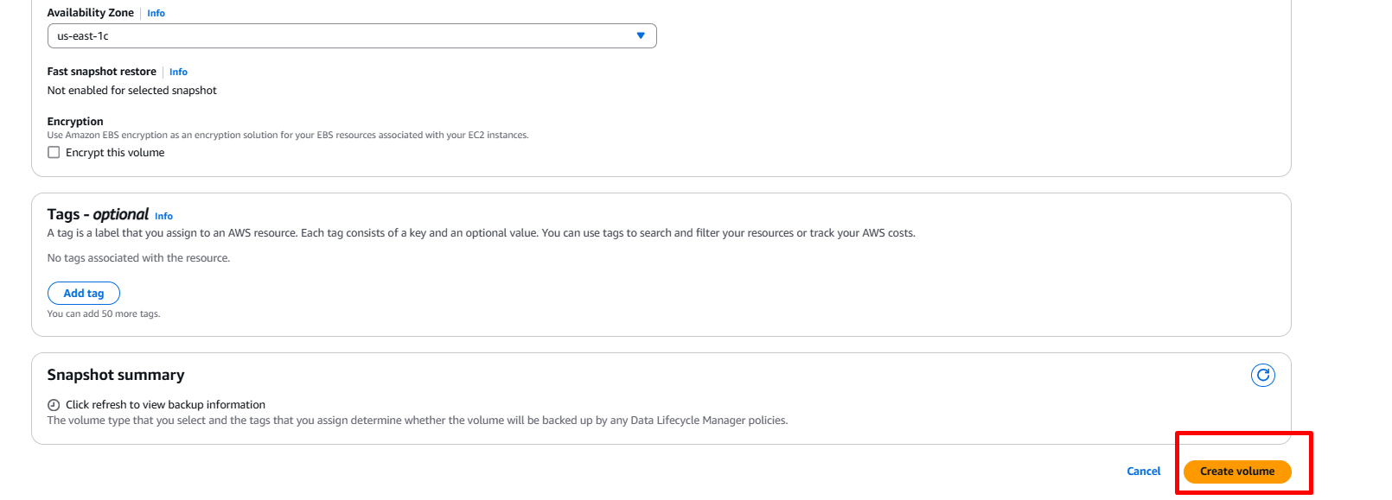

**Step9: Select the volume 🡪 once volume is available state attach the volume to linux-server-3**

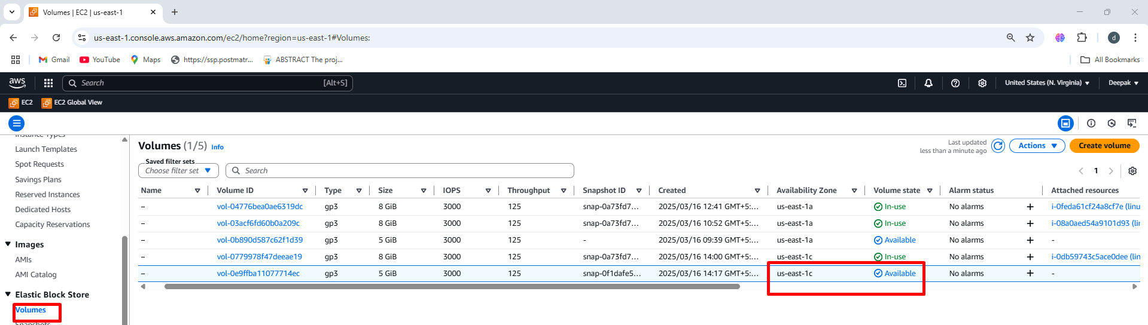

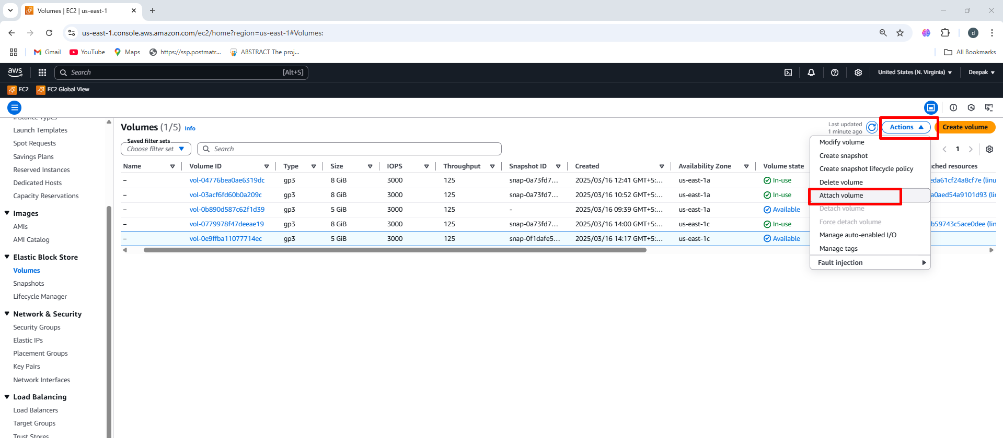

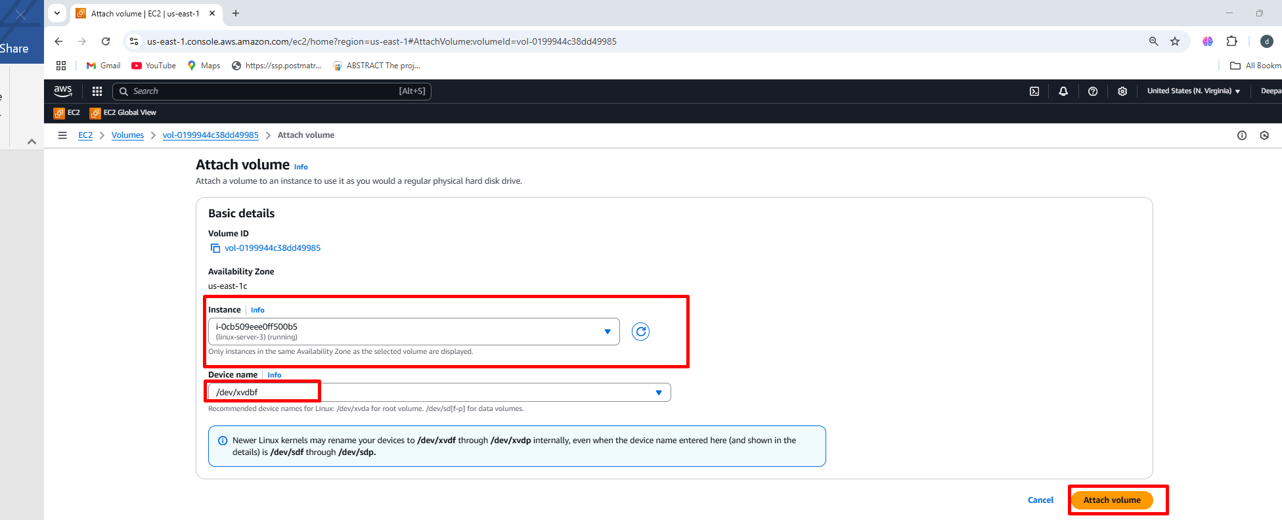

**Step10:** Follow the same step to connect the mobaXterm in linux-server-1 🡪 below image is a output screen of linux-server-3 Which is connected through mobaxterm

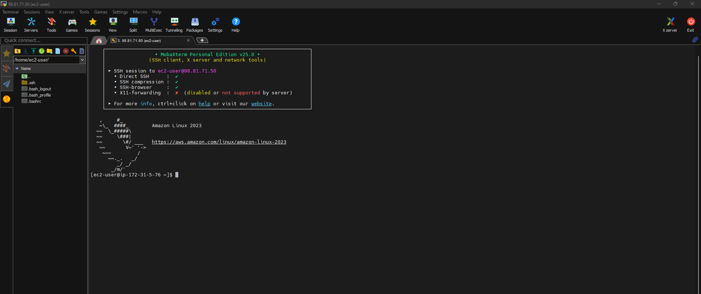

**Step11:** Check if the **Volume is Attached 🡪 lsblk**

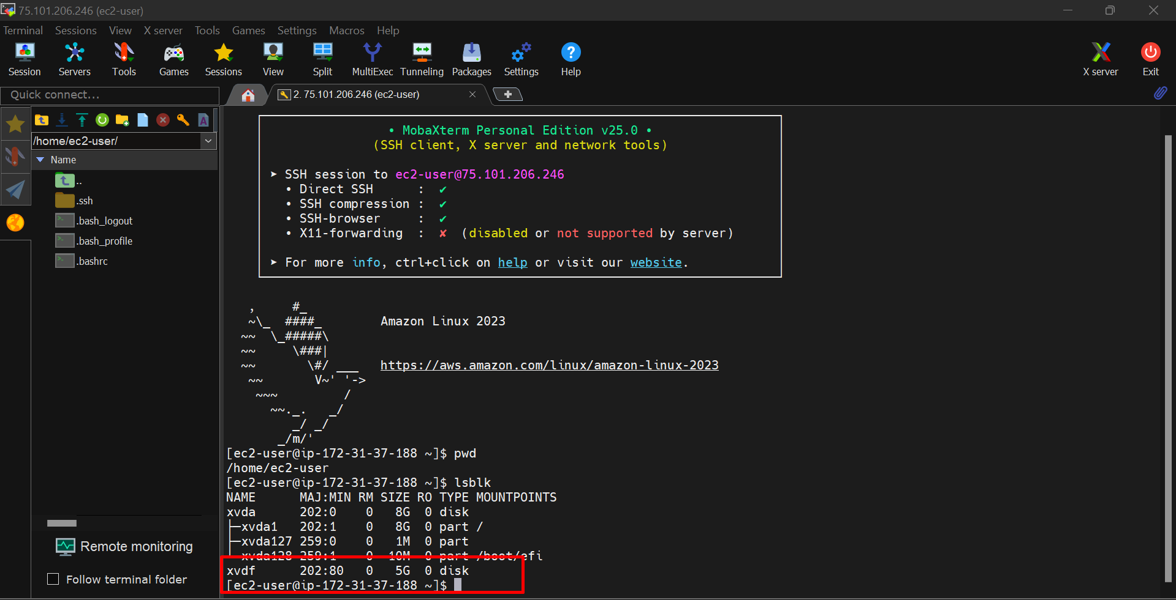

**Step12:** To check the volume format **🡪sudo file -s /dev/xvdf**

**The below image shows attached volume filesystem data**

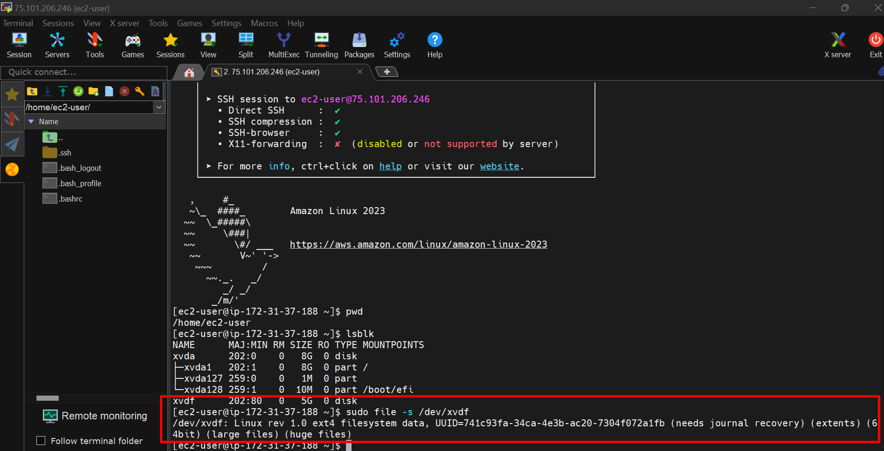

**Step13:**  To display disk space 🡪 **df -h**

The df -h command is used to display the disk space usage of filesystems in a human-readable format.

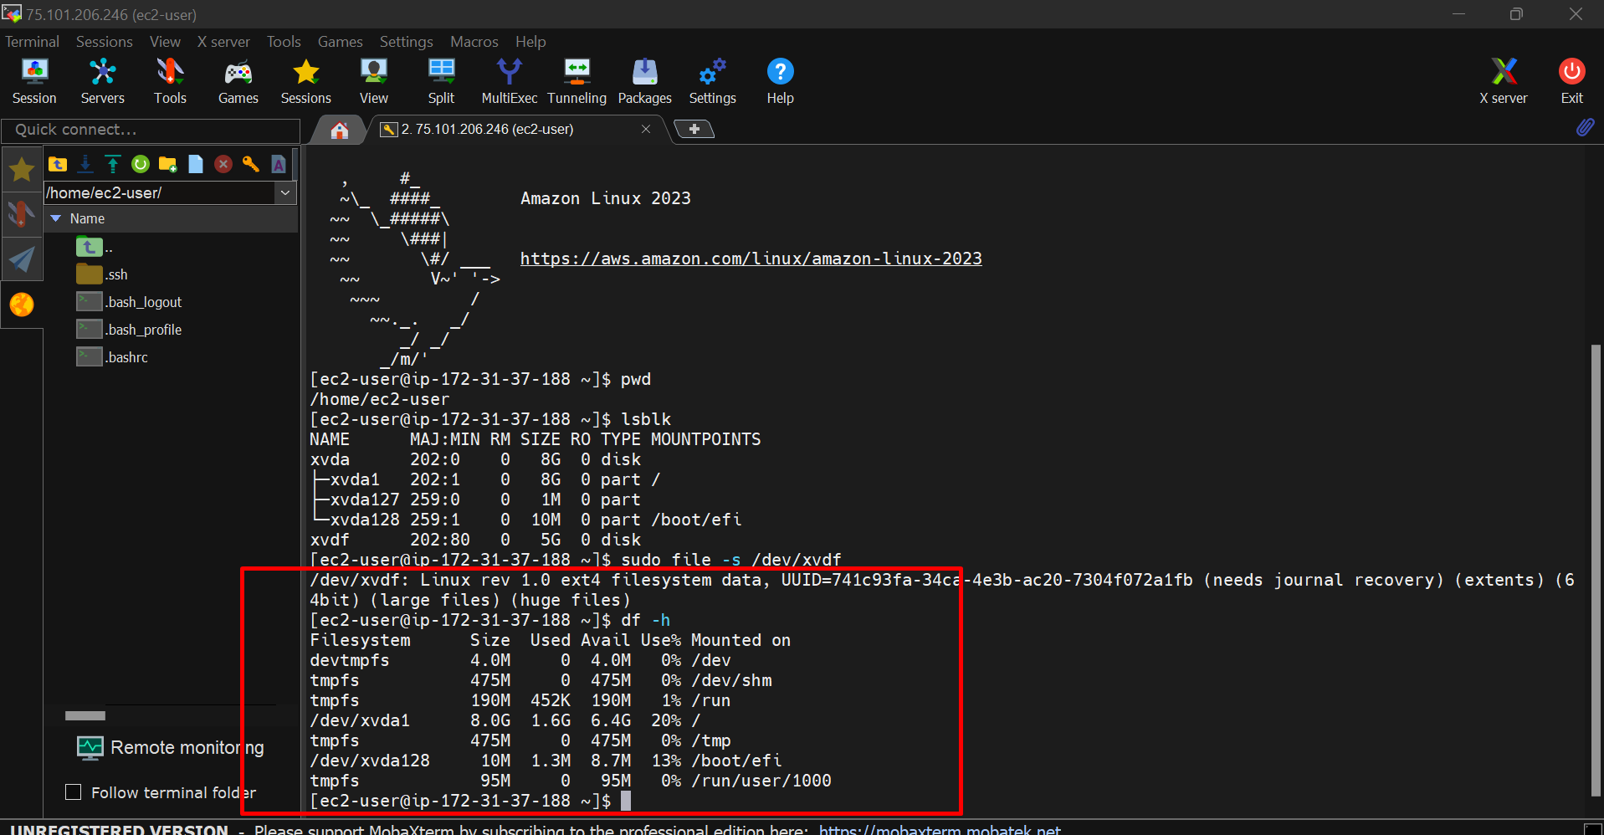

**Step14:**  Create a directory Volume-F 🡪 mkdir volume-F

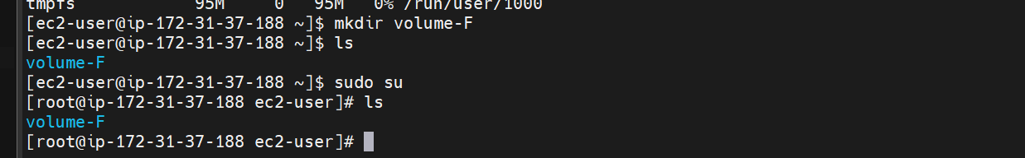

**Step15:**  To check the mountpoint 🡪 **mountpoint volume-F**

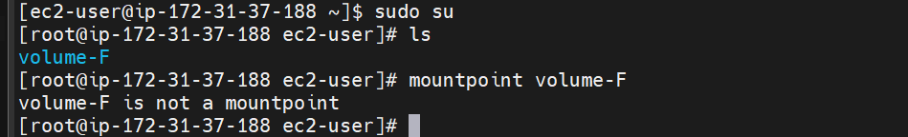

**Step16:**  To connect the EBS volume to directory 🡪 **mount /dev/xvdf volume-F**

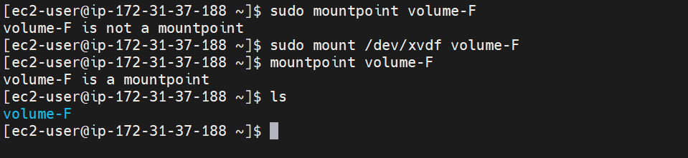

**Step17:**  Change directory to volume-d 🡪 **cd volume-E 🡪 attached volume data as found**

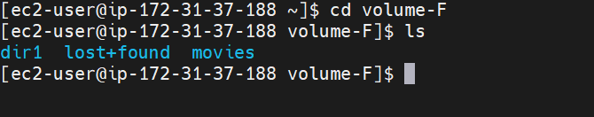

**Step18:**  Change directory to dir1 🡪 **cd dir1 🡪 attached volume data as found**

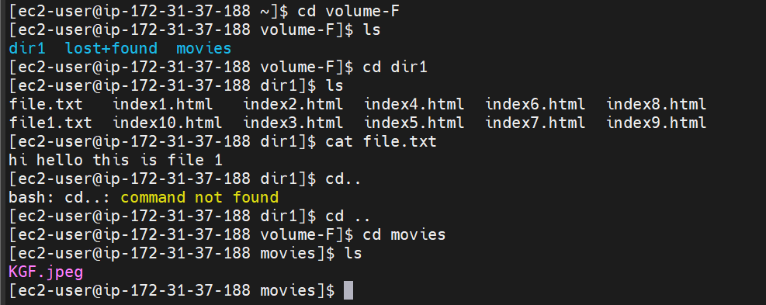

**Step19:** Exit from directory to ec2-user 🡪 umount volume-F 🡪 Select actions in volume and detach ,to attach for other availability zone

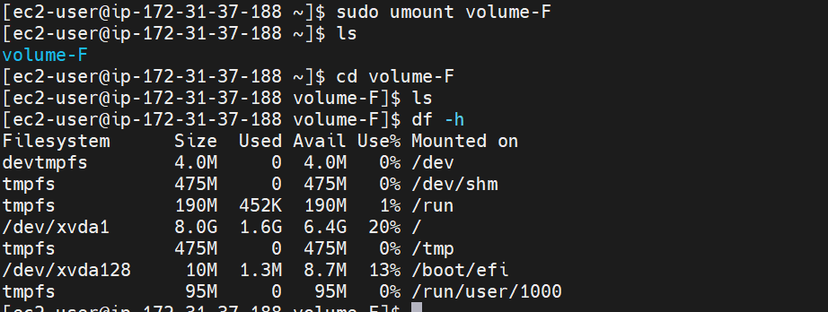

To connect an **EBS (Elastic Block Store)** volume to an **EC2 instance** **with different region**, follow these steps:

To launch Instance follow the same steps which we created in same availability zone

**Step1:** We need to copy the snapshot from the **linux-server-3**

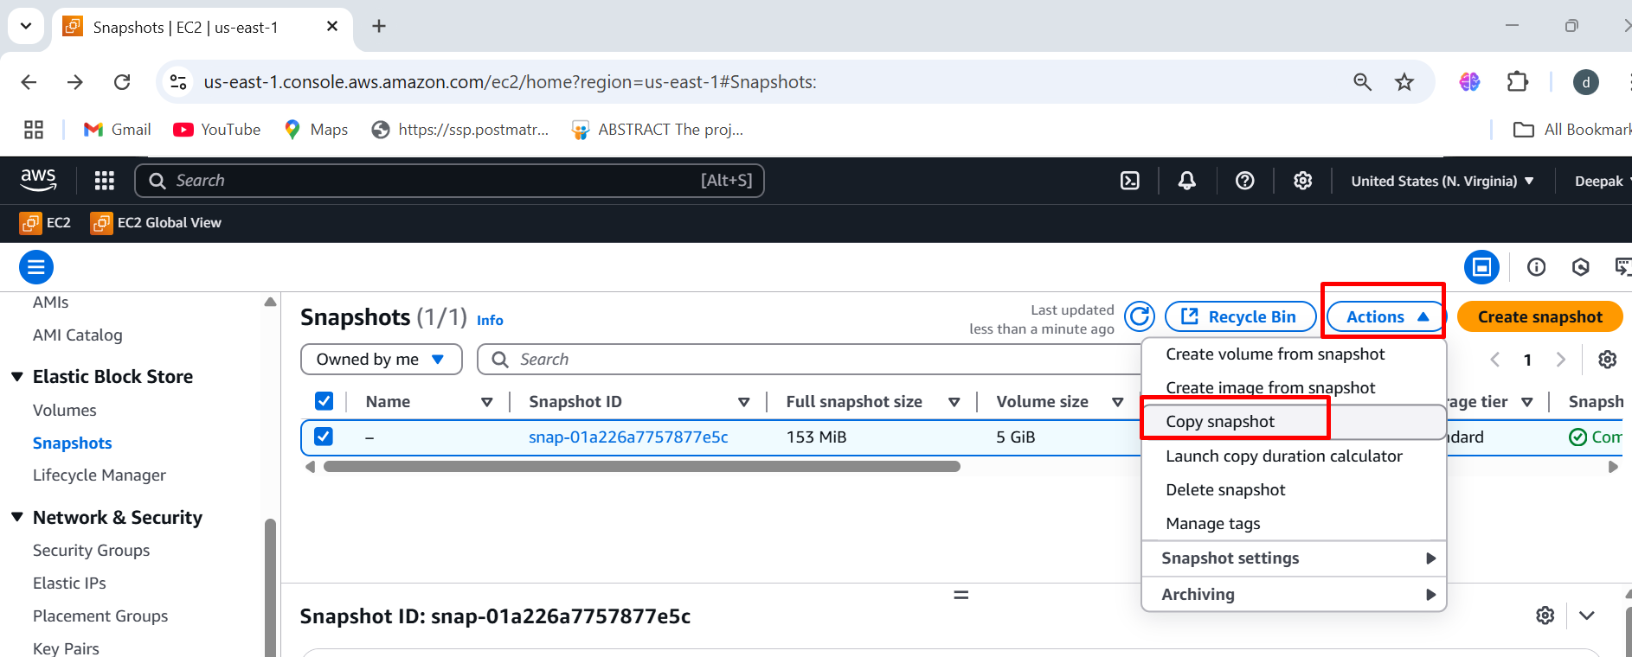

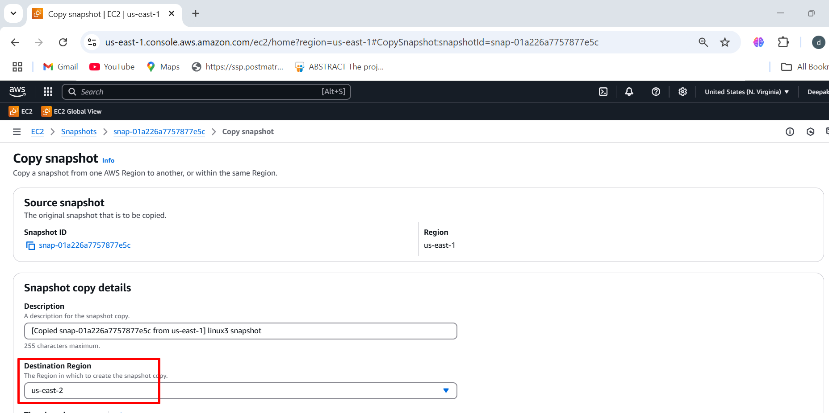

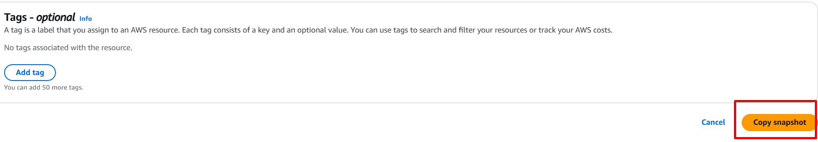

**Step3:** We need to open the different **region us-east-2a** 🡪 it will **directly display copied snapshot**

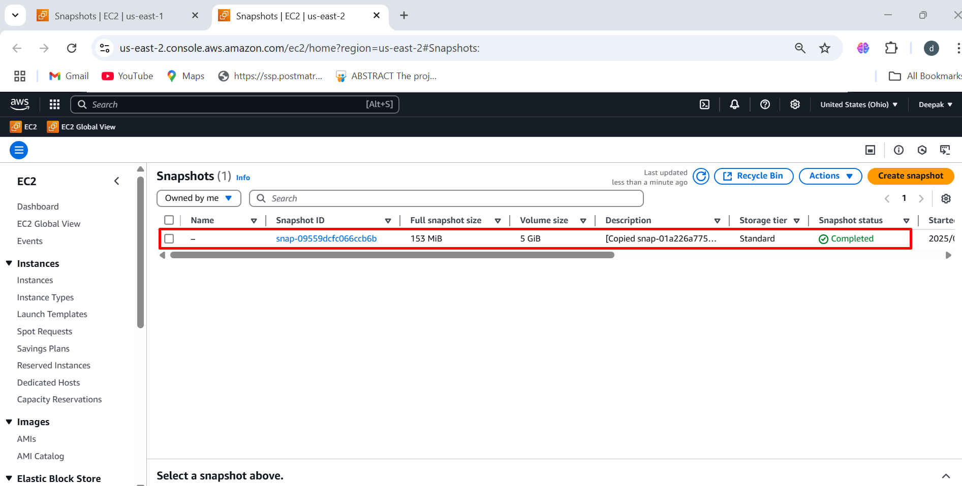

**Step4:** To launch Instance follow the same steps which we created in Linux-server-1

**Under the network setting we need to choose the availability zone**

**(us-east-2a)**

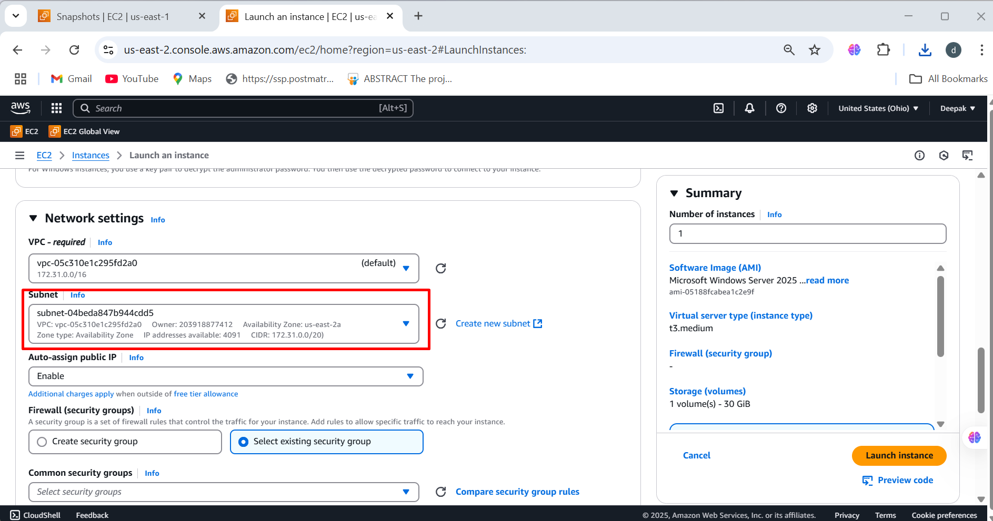

**Step5: Create volume from snapshot 🡪 Choose Availability Zone (us-east-2a) to ensure it matches the target instance 🡪Attach the Volume** to an instance in **us-east-2a** 🡪 create volume

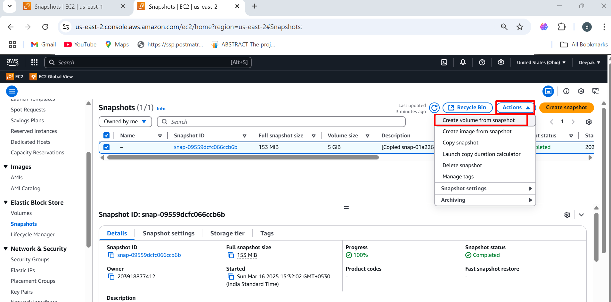

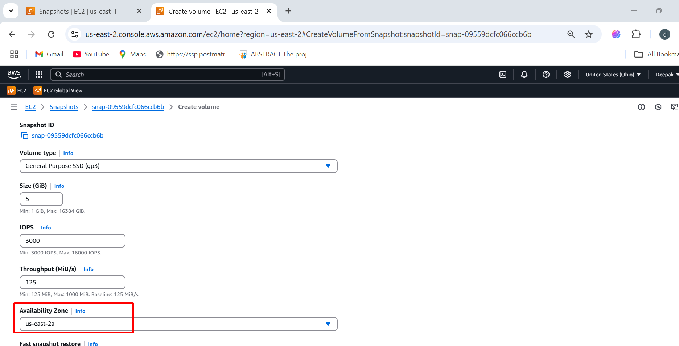

**Step6:** Volumes 🡪 select the volume **(us-east-2a)** 🡪 action 🡪 Attach the volume 🡪 select the instance and device name 🡪 click on attach volume

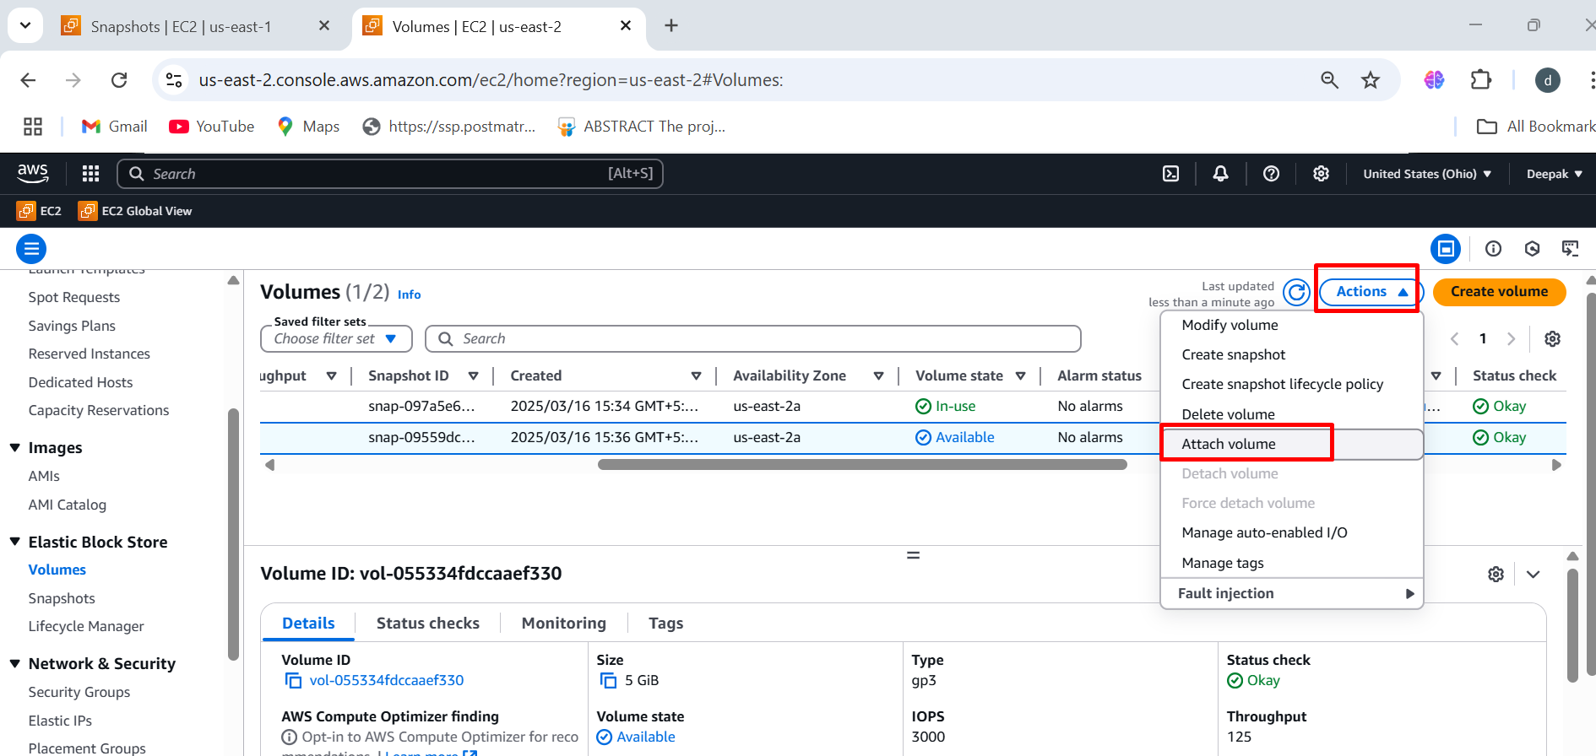

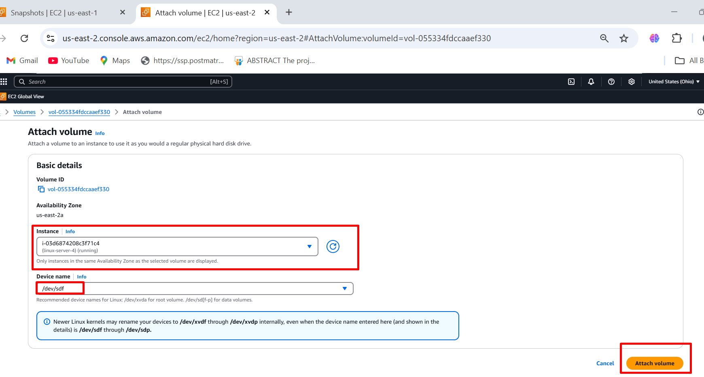

**Step7:** Follow the same step to connect the **mobaXterm in linux-server-1** 🡪 below image is a output screen of linux-server-4 Which is connected through mobaxterm

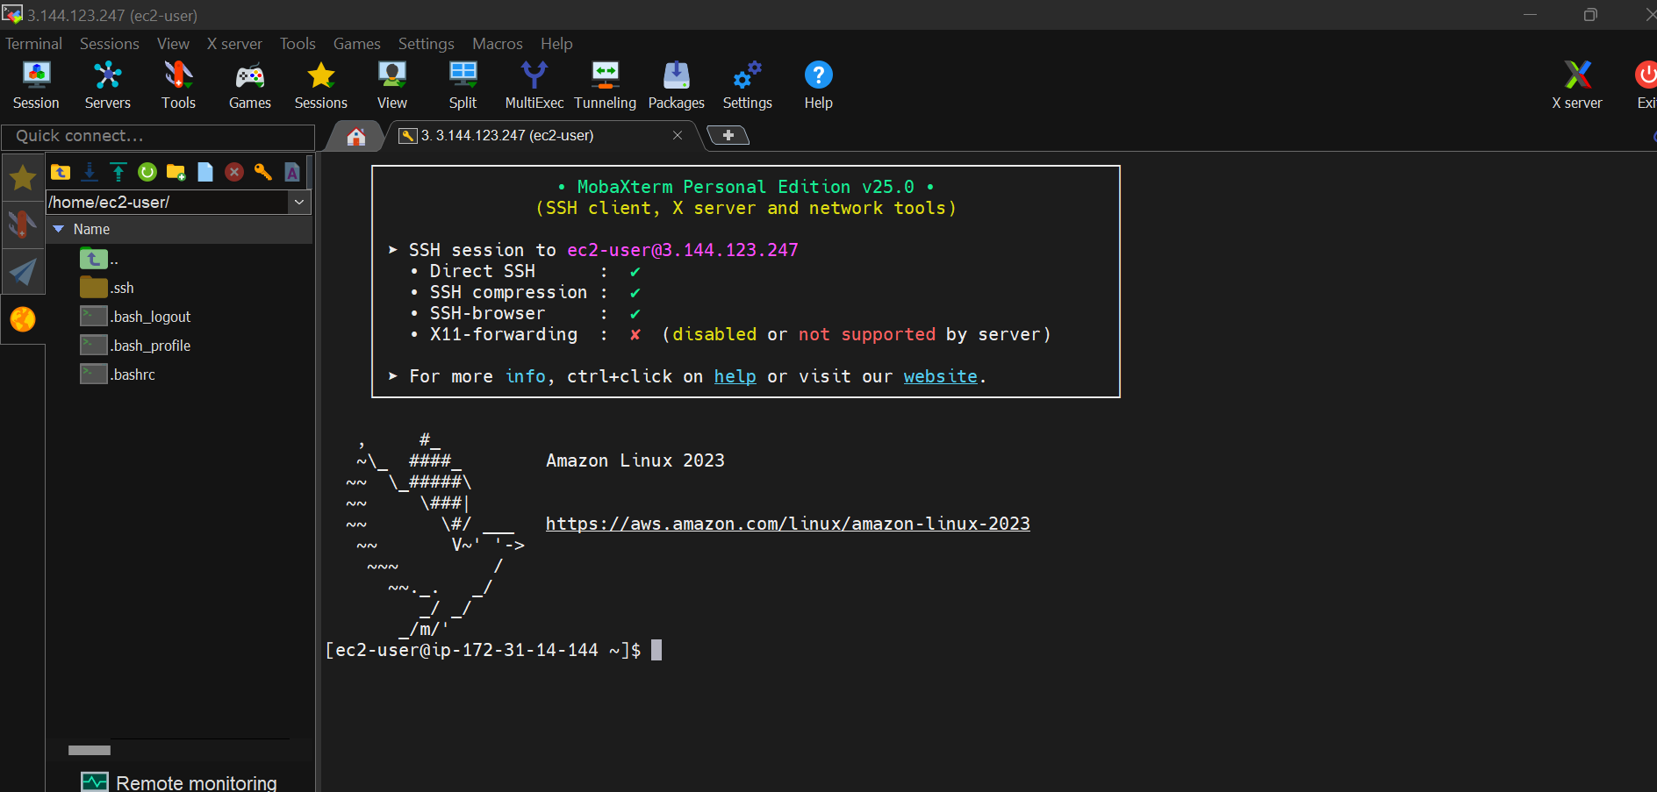

**Follow the same step in connecting in above different region from step 11 to step 17 to block storage 🡪 volume format 🡪 mountpoint 🡪 Connecting the EBS volume to dir .**

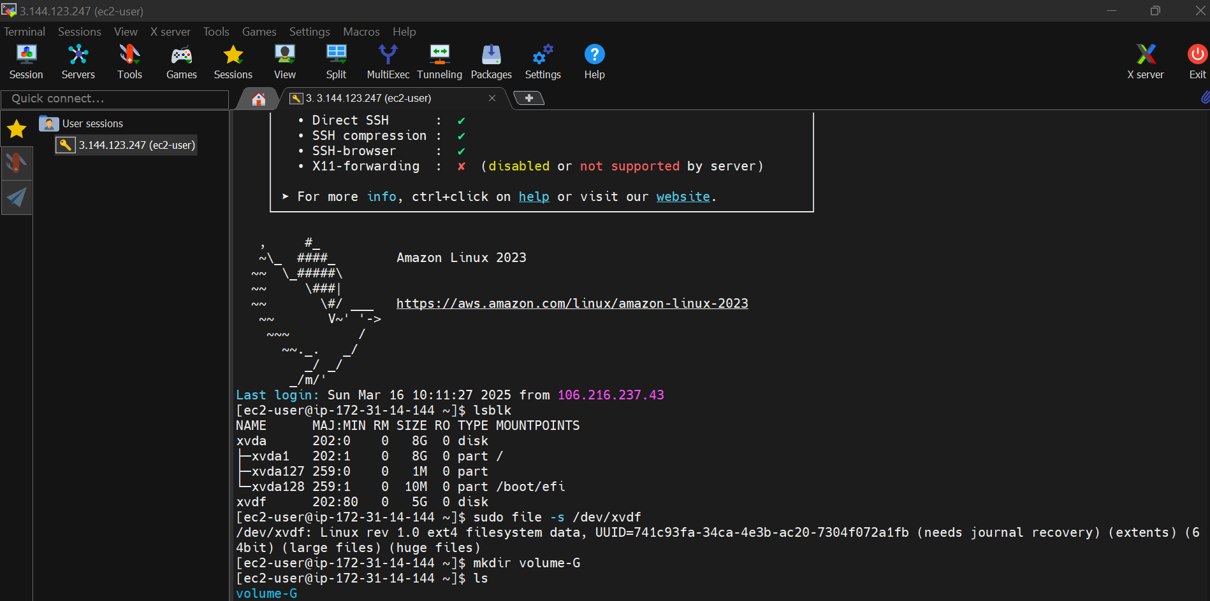

**Accessing the transferred data from different region 🡪 output in (us-east-2a) region**

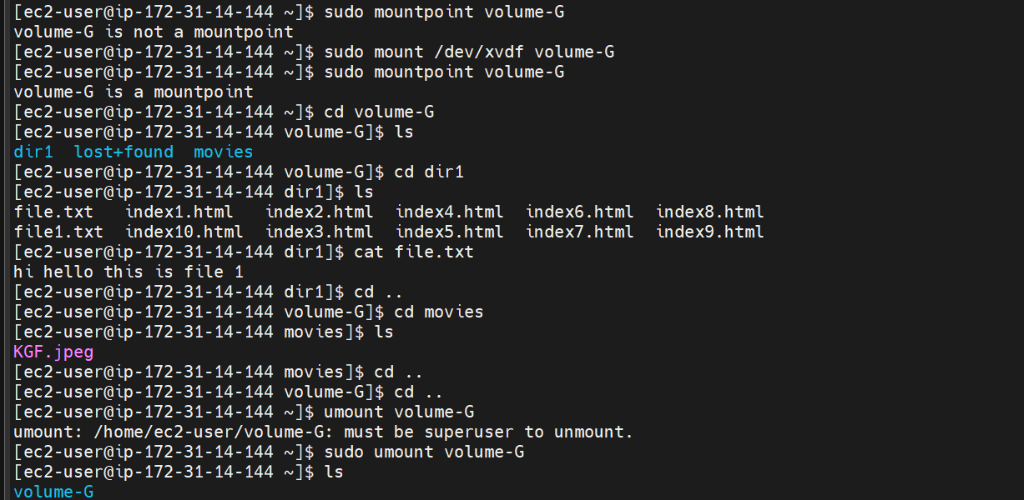

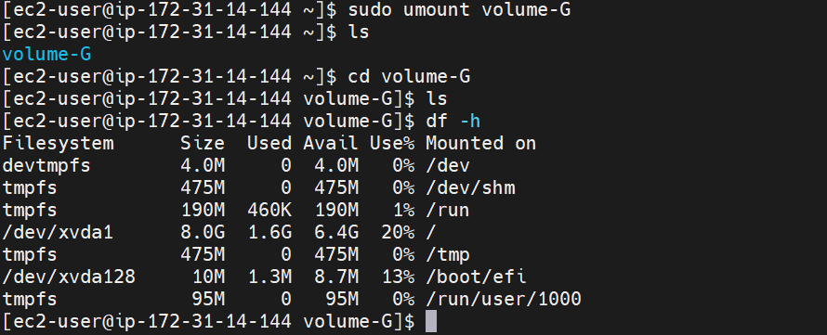

**CONCLUSION:**

This process allows you to effectively move an EBS volume between regions, ensuring that you can access and utilize the data in the new region. Just keep in mind that copying snapshots between regions incurs additional costs and may take some time depending on the size of the data.